Similar Shapes

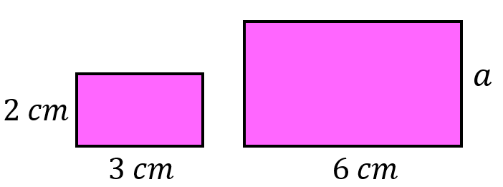
Find the missing lengths in these pairs of similar shapes.
(a)

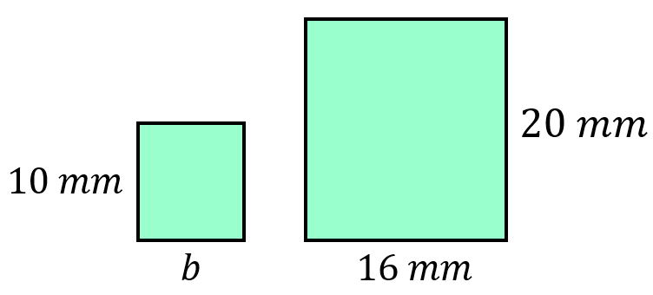
(b)

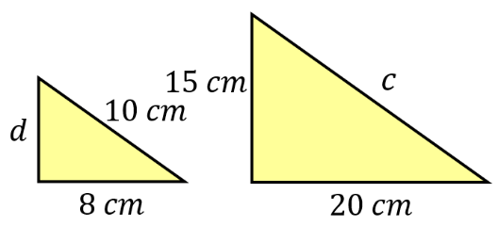
(c)

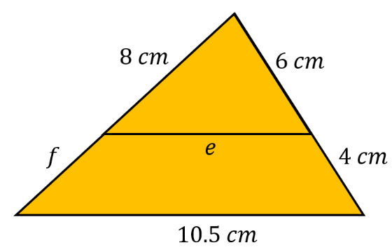
By drawing both shapes separately, find the missing lengths in these diagrams.
(d)

$$3 cm$$

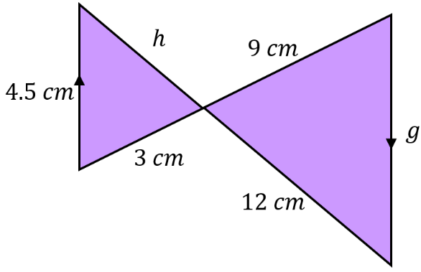
(e)

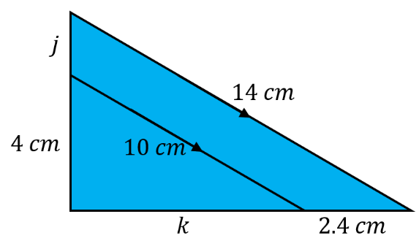
By drawing both shapes separately, find the missing lengths.
(f)

Similar Shapes

Find the missing lengths in these pairs of similar shapes.
(a)

(b)

(c)

By drawing both shapes separately, find the missing lengths in these diagrams.
(d)

$$3 cm$$

(e)

By drawing both shapes separately, find the missing lengths.
(f)

