🅒🅡🅐🅒🅚 🅣🅗🅔 🅒🅞🅓🅔 |  | 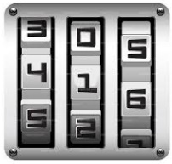
Solve $x+14=40$ | Solve $3x-2=34$
Solve $5x-3=17$ | Solve $2x=50$
Solve $3-7x=24$ | Solve $5(x+5)+3=13$
Solve $x+20=2(x+6)$ | Solve $4x-40=10-x$
Solve $5x-4 = 1+6x$ | Solve $3\left(2x – 7\right)=15$
Solve $48+x=12+5x$ | Solve $5x+12=12x-9$
Solve $3(x-2)+4=10+x$ | Solve $5(x-4)+25=0$
Solve$8x-1=6x-5$ | Solve $3\left(2x+5\right)+x=2(2-x)+2$
Solve $3x-21=3-x$ | Solve $\frac{2x}{5}=12$
Solve $\frac{2x-8}{6}=3$ | Solve $\frac{x+3}{4}=\frac{3(x-1)}{6}$
To get the code, add all your answers together.

