Plotting Cumulative Frequency Graphs
(a) |  | (b)
Plot a cumulative frequency graph from the data shown in the table. | 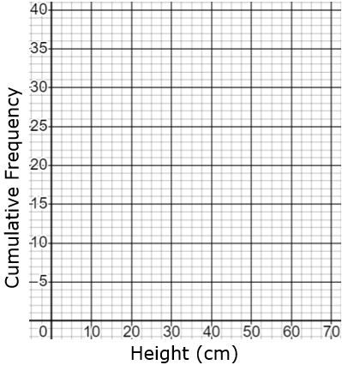 | Plot a cumulative frequency graph from the data shown in the table. | 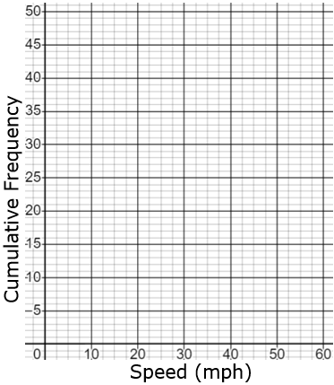
  Height (cm) | Cumulative Frequency
  $$10<h≤20$$ | 3
  $$10<h≤30$$ | 8
  $$10<h≤40$$ | 19
  $$10<h≤50$$ | 29
  $$10<h≤60$$ | 35
  $$10<h≤70$$ | 40
  Speed (mph) | Cumulative Frequency
  $$0<s≤10$$ | 6
  $$0<s≤20$$ | 10
  $$0<s≤30$$ | 22
  $$0<s≤40$$ | 35
  $$0<s≤50$$ | 44
  $$0<s≤60$$ | 50
(c) |  | (d)
Plot a cumulative frequency graph from the data shown in the table. | 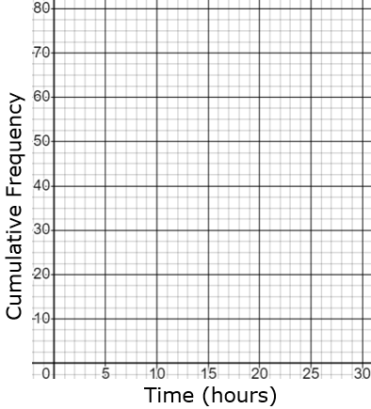 | Plot a cumulative frequency graph from the data shown in the table. | 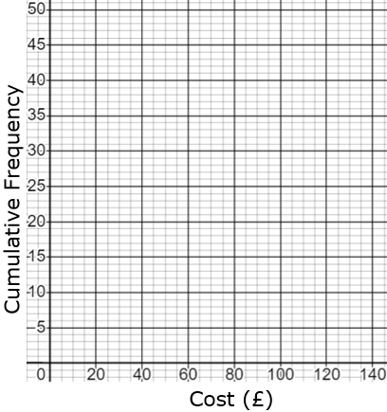
  Time (hours) | Cumulative Frequency
  $$0<h≤5$$ | 9
  $$0<h≤10$$ | 21
  $$0<h≤15$$ | 38
  $$0<h≤20$$ | 60
  $$0<h≤25$$ | 73
  $$0<h≤30$$ | 80
  Cost (£) | Cumulative Frequency
  $$20<c≤40$$ | 4
  $$20<c≤60$$ | 11
  $$20<c≤80$$ | 19
  $$20<c≤100$$ | 36
  $$20<c≤120$$ | 45
  $$20<c≤140$$ | 48

