Scale Diagrams
Scale 1 cm : 100 m  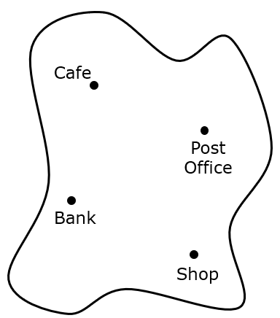 | (a) | (b) | (c)
 | Donna walks from the shop to the post office. How far has she walked? | Adil cycles from the café to the shop. How far has he cycled? | Yusuf lives 700 m from the café. How far would this be on the map?
 | (d) | (e) | (f)
 | Mercy walks from the café to the bank, then to the shop. How far has she walked in total? | Otis lives 1.2 km from the bank. How far would this be on the map? | Teresa lives 300 m from the shop. She walks to the shop, then the bank, then back to the shop, then home. How far has she travelled in km?
Scale 1 cm : 2 m  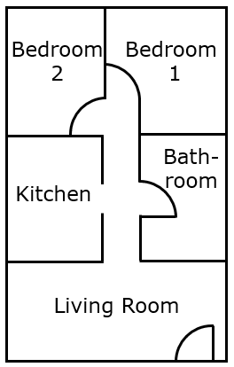 | (g) | (h) | (i)
 | What is the actual width of the living room? | What is the width of the bathroom door in real-life? | The actual width of the living room window is 1 metre. What would this width measure on the scale diagram?
 | (j) | (k) | (l)
 | Find the real-life dimensions of bedroom 2. | Find the actual area of the kitchen floor. | A bed measures 120 cm by 200 cm. What measurements would the bed have on the scale diagram?

