Multi-Step Pythagoras’ Theorem
(a) | (b)
Find $x$ and $y$, rounding to 1 decimal place where necessary.  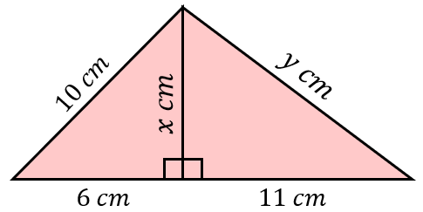 | Find $x$ and $y$, rounding to 1 decimal place where necessary.  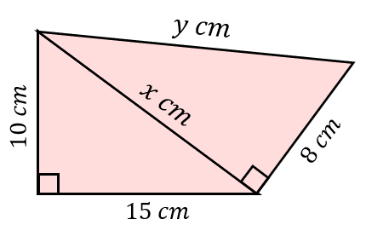
(c) | (d)
Find $x$, to 1 decimal place.  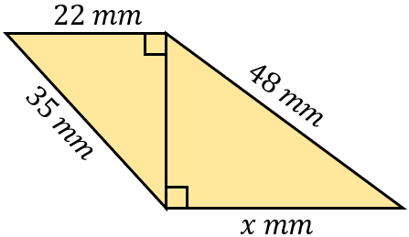 | Find $x$, to 1 decimal place.  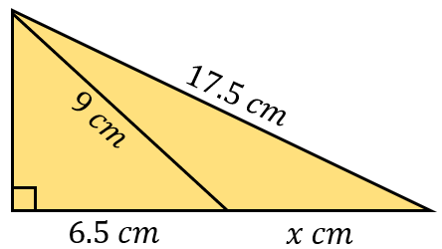
(e) | (f)
Find $x$, to 1 decimal place.  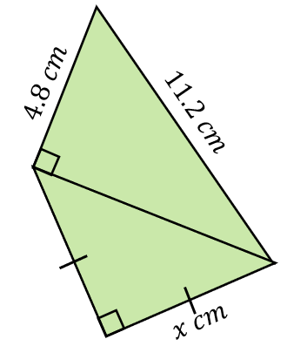 | Find $x$, to 1 decimal place.  