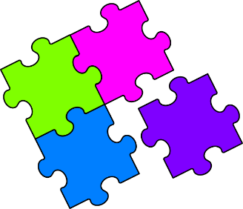
Match-Up
Adding and Subtracting Algebraic Fractions

1 | $$\frac{x}{6}+\frac{x}{4}$$ | 6 | $$\frac{7x}{10}+\frac{3x}{4}$$ | 11 | $$\frac{3}{x}+\frac{5}{x^{2}}$$
2 | $$\frac{x}{5}-\frac{x}{7}$$ | 7 | $$\frac{4}{x}+\frac{2}{x}$$ | 12 | $$\frac{5}{x^{2}}-\frac{3}{x}$$
3 | $$\frac{3x}{4}+\frac{2x}{5}$$ | 8 | $$\frac{5}{4x}+\frac{1}{x}$$ | 13 | $$\frac{7}{xy}+\frac{4}{x^{2}}$$
4 | $$\frac{5x}{6}-\frac{3x}{8}$$ | 9 | $$\frac{9}{4x}-\frac{1}{2x}$$ | 14 | $$\frac{4}{x}+\frac{7}{x^{2}y}$$
5 | $$\frac{11x}{20}-\frac{x}{3}$$ | 10 | $$\frac{8}{5x}-\frac{1}{2x}$$ | 15 | $$\frac{1}{2y}-\frac{2}{x^{2}}$$
A | $$\frac{11x}{24}$$ | F | $$\frac{5-3x}{x^{2}}$$ | K | $$\frac{6}{x}$$
B | $$\frac{7}{4x}$$ | G | $$\frac{5x}{12}$$ | L | $$\frac{x^{2}-4y}{{2x}^{2}y}$$
C | $$\frac{7x+4y}{x^{2}y}$$ | H | $$\frac{29x}{20}$$ | M | $$\frac{23x}{20}$$
D | $$\frac{11}{10x}$$ | I | $$\frac{9}{4x}$$ | N | $$\frac{4xy+7}{x^{2}y}$$
E | $$\frac{2x}{35}$$ | J | $$\frac{3x+5}{x^{2}}$$ | O | $$\frac{13x}{60}$$

1 | 2 | 3 | 4 | 5 | 6 | 7 | 8 | 9 | 10 | 11 | 12 | 13 | 14 | 15
1

