Trigonometry in 3D

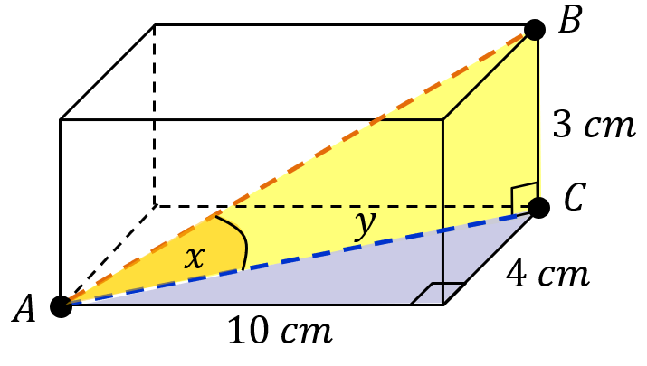
Find the angle $\hat{BAC}$
(a)

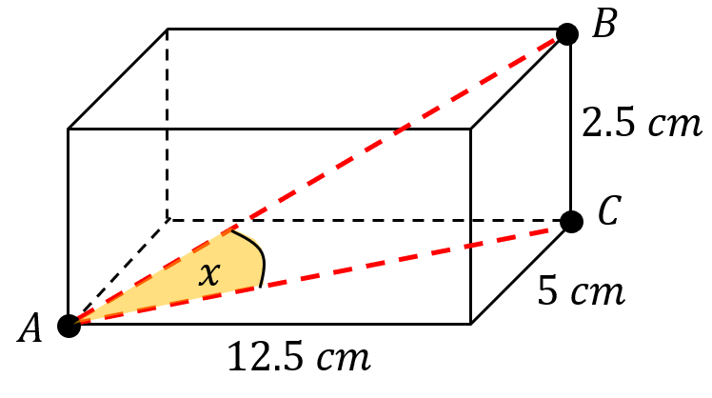
(b)

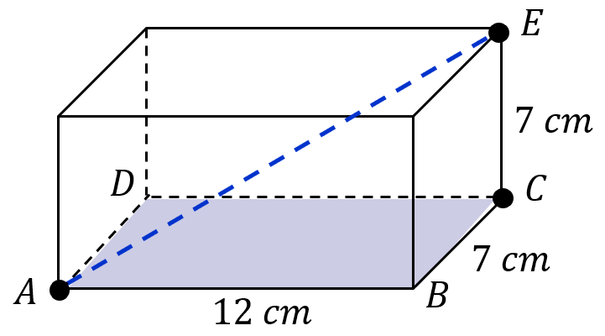
Find the angle between the line EA and the plane ABCD
(a)

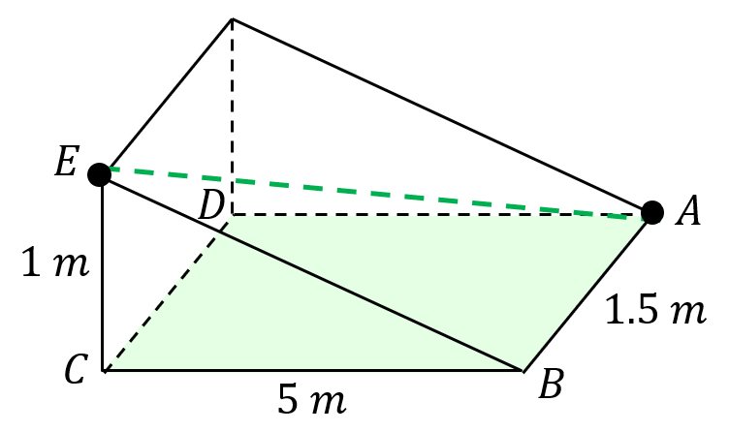
(b)

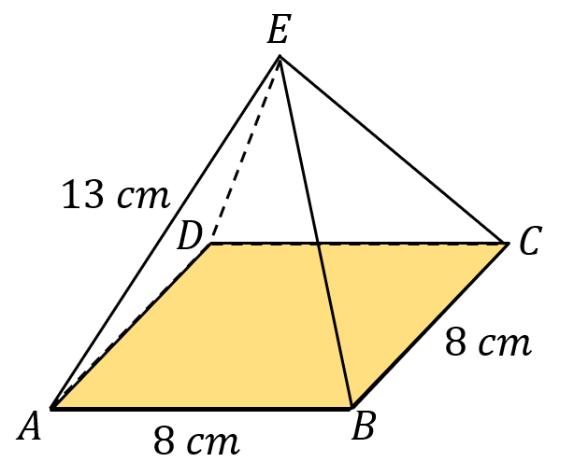
(c)

Trigonometry in 3D

Find the angle $\hat{BAC}$
(a)

(b)

Find the angle between the line EA and the plane ABCD
(a)

(b)

(c)

