Theoretical Probability with Spinners
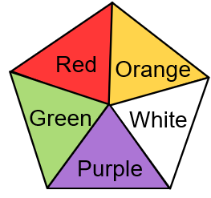  The fair five-sided spinner shown is spun once. |  | (a) | (b) |  | (c) |  | (d)
 |  | What is the probability of the spinner landing on green? | What is the probability of the spinner landing on purple or white? |  | What is the probability of the spinner landing on black? |  | Sania spins the spinner $50$ times. How many times would she expect it to land on orange?
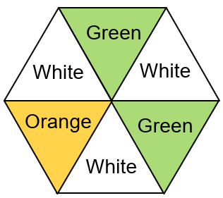  The fair six-sided spinner shown is spun once. |  | (e) | (f) |  | (g) |  | (h)
 |  | What is the probability of the spinner landing on white? | What is the probability that the spinner does not land on orange? |  | Which is more likely – the spinner landing on white or the spinner landing on green? |  | Lola spins the spinner $120$ times. How many times would she expect it to land on white?
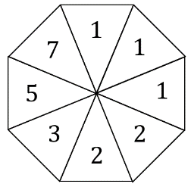  The fair eight-sided spinner shown is spun once. |  | (i) | (j) |  | (k) |  | (l)
 |  | What is the probability of the spinner landing on a number less than $10$? | What is the probability of the spinner landing on an odd number? |  | What is the probability of the spinner not landing on a prime number? |  | Aidan spins the spinner $80$ times. How many times would he expect it to land on a $2$ or $3$?
(m) |  |  |  | (n)
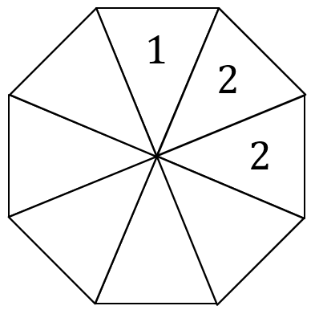 | Here is a fair eight-sided spinner. Complete the spinner so that:  - The probability of landing on a $1$ is the same as the probability of landing on a $2$  - The probability of landing on a $4$ is $\frac{1}{8}$  - The total of all the numbers on the spinner is $16$. |  |  |  |  | Here is a fair eight-sided spinner. Complete the spinner so that:  - The probability of landing on an odd number is $0.5$  - The probability of spinning a $3$ is the same as the probability of spinning a $4$  - All the numbers on the spinner are less than $8$  - The total of all the numbers is $24$.

