Fill In The Blanks…
Equation of a Straight Line

Equation of Straight Line | Graph | Gradient | Y-Intercept | A Point on the Line | Another Point on the Line
$$y=x-3$$ | 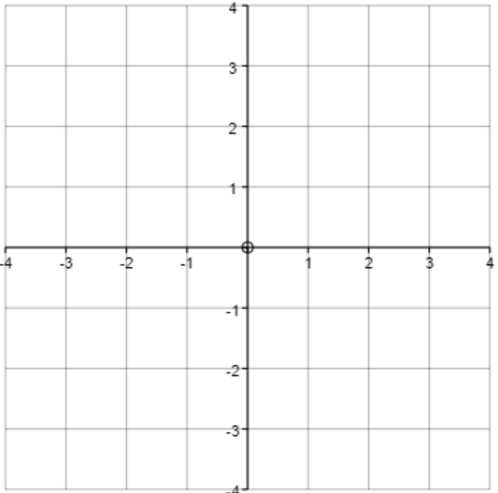 |  |  | $$(-5, )$$ | $$( , 10)$$
$$y=1+2x$$ |  |  |  | $$(2, )$$ | $$( , -7)$$
 |  | $$-1$$ | $$(0, 2)$$ | $$(2, )$$ | $$( , -7)$$
 |  | $$-3$$ |  | $$(1, 0)$$ | $$( , 9)$$
 |  |  |  | $$(-8, )$$ | $$( , 2)$$
 |  |  |  | $$(1, 1)$$ | $$(5, 13)$$

