Area of a Trapezium

Find the area of each of these trapezia. Give units with your answer.
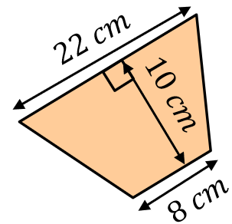
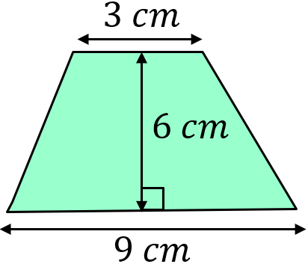
(a) (b)

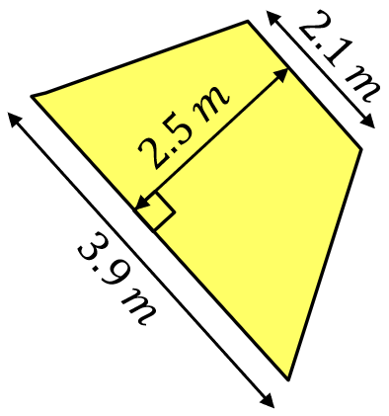
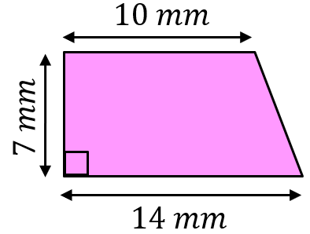
(c) (d)

Calculate the area each of these trapezia. Give units with your answer.
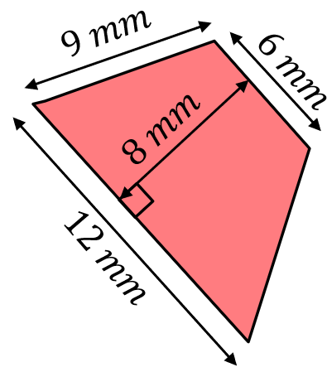
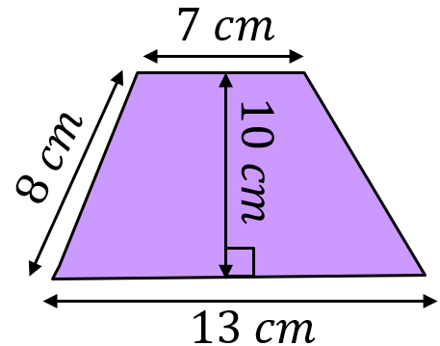
(a) (b)

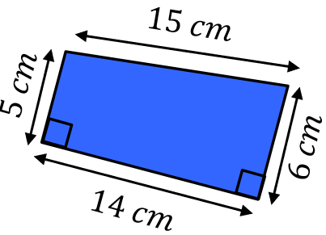
(c)
(d)
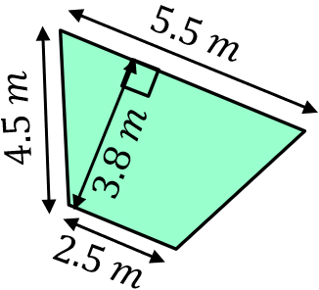

Find the missing measurements in each of these trapezia given their areas.
(a) $Area=48 {cm}^{2}$ (b) $Area=72 {cm}^{2}$
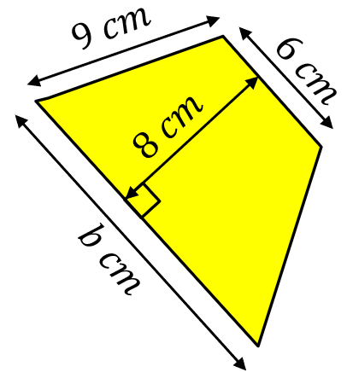
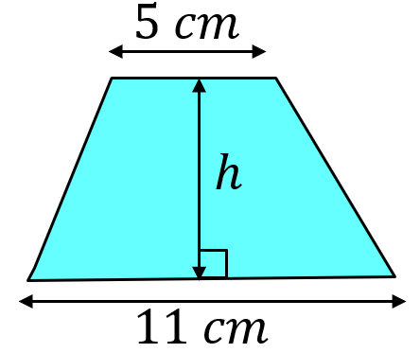

Area of a Trapezium

Find the area of each of these trapezia. Give units with your answer.
(a) (b)

(c) (d)

Calculate the area each of these trapezia. Give units with your answer.
(a) (b)

(c)
(d)

Find the missing measurements in each of these trapezia given their areas.
(a) $Area=48 {cm}^{2}$ (b) $Area=72 {cm}^{2}$

