Equating Coefficients in Vectors

Find the values of $λ$ and $μ$ by equating coefficients of $a$ and $b$.
(a) $4a+λb=μa+6b$
(b) $λa-5b=-2a+μb$
(c) $λa+μb=2a+6b+3a-3b$
(d) $-3a+λb=2a-b+μa+5b$
(e) $2\left(2a-μb\right)+3a+10b=λa+6b$

In the vector diagrams shown, find the values of $λ$ and $μ$.
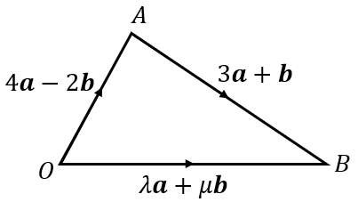
(a)

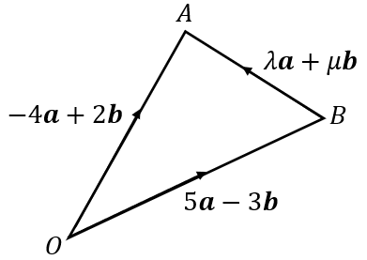
(b)

In the vector diagrams shown, find the values of $λ$ and $μ$.
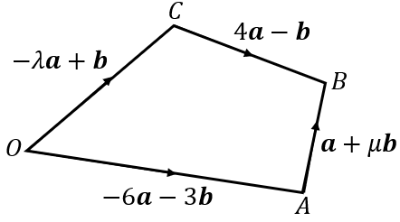
(a)

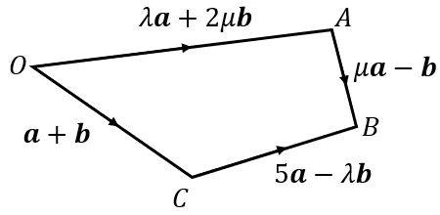
(b)
Equating Coefficients in Vectors

Find the values of $λ$ and $μ$ by equating coefficients of $a$ and $b$.
(a) $4a+λb=μa+6b$
(b) $λa-5b=-2a+μb$
(c) $λa+μb=2a+6b+3a-3b$
(d) $-3a+λb=2a-b+μa+5b$
(e) $2\left(2a-μb\right)+3a+10b=λa+6b$

In the vector diagrams shown, find the values of $λ$ and $μ$.
(a)

(b)

In the vector diagrams shown, find the values of $λ$ and $μ$.
(a)

(b)

