More Solving Trigonometric Equations Using Graphs
Use your calculator and the trigonometric graphs to find all values of the angle between 0º and 360º
$$y=\sin{x}$$ |  | $$y=\cos{x}$$ |  | $$y=\tan{x}$$
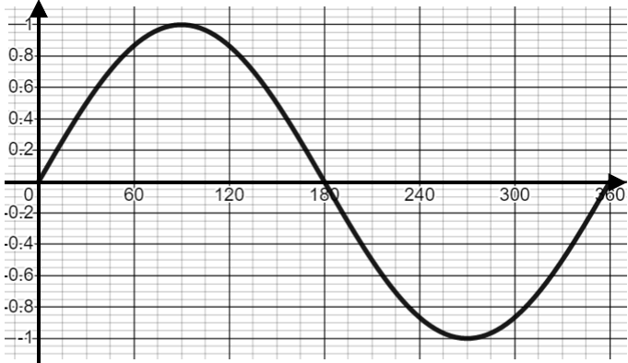 |  | 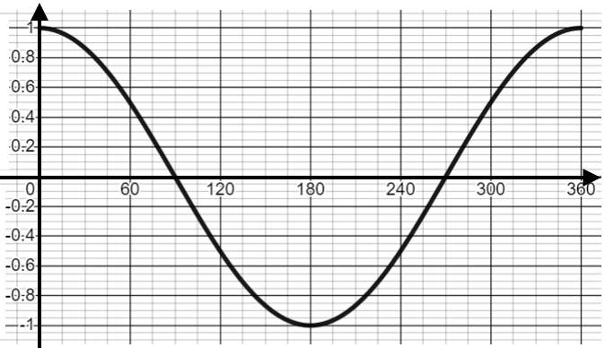 |  | 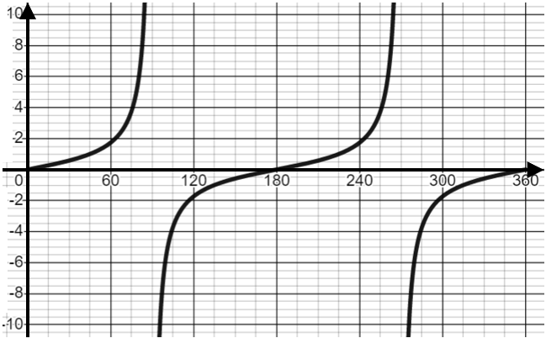
$$\sin{x}=-0.4$$ | $$\cos{x}=-0.1$$ |  | $$\tan{x}=-3.7$$ |  | $$\cos{x}=-0.65$$
$$\sin{x}=-0.88$$ | $$\cos{x}=-0.25$$ |  | $$\tan{x}=-6$$ |  | $$\sin{x}=-0.97$$
$$\cos{x}=-0.31$$ | $$\sin{x}=-0.745$$ |  | $$\tan{x}=-2.3$$ |  | $$\cos{x}=-0.523$$
$$\sin{x}=-0.5$$ | $$\tan{x}=-1$$ |  | $$\sin{x}=-1$$ |  | $$\cos{x}=-1$$

