Fill In The Blanks…
Composite One-Step Functions

Question | Input | 1st Function | 2nd Function | Output | Answer
$$f\left(x\right)=5x g\left(x\right)=x+2$$  Find $fg(x)$ | 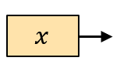 | 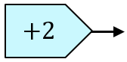 | 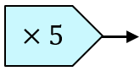 | 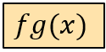 | $$fg\left(x\right)=5(x+2)$$
$$f\left(x\right)=5x g\left(x\right)=x+2$$
Find $gf(x)$
$$f\left(x\right)=x-1 g\left(x\right)=x^{2}$$  Find $fg(x)$ |  | 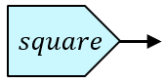 | 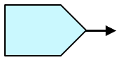
$$f\left(x\right)=x+3 g\left(x\right)=\sqrt{x}$$
Find $gf(x)$
$$f\left(x\right)=\frac{x}{2} g\left(x\right)=x+7$$
Find $fg(x)$
$$g\left(x\right)=x-4 h\left(x\right)=\sqrt{x}$$
Find $gh(x)$
$$f\left(x\right)=\frac{1}{x} g\left(x\right)=x^{2}$$
Find $gf(x)$

