True or False?

Linear Inequalities
For each statement, circle the correct response.
1 | The inequality $x<3$ is represented on the number line as : | 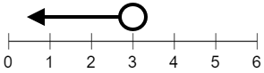 | True | False
2 | The inequality $1<x≤3$ is represented on the number line as : | 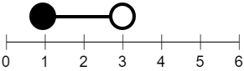 | True | False
3 | The integers $2, 3$ and $4$ all satisfy the inequality  $x<4$ |  | True | False
4 | The integers $-1, 0$ and $1$ are the only integers to satisfy the inequality $-1≤x<2$ |  | True | False
5 | The only integer to satisfy both inequalities  $-1≤x<4$ and $2<x≤6$ is $3$. |  | True | False
6 | The solution to the inequality $x-3>5$  is $x>2$ |  | True | False
7 | The solution to the inequality $-4x≤20$  is $x≥-5$ |  | True | False
8 | The solution to the inequality $20>3x-1$  is $x<7$ |  | True | False
9 | The integers $-3, -2$and $-1$ all satisfy the inequality  $$-2≤x+1<0$$ |  | True | False
10 | The solution to the inequality $-8≤8x<56$  is $-1≥x>7$ |  | True | False
11 | The solution to the inequality $2x-4<6-3x≤21$  is $-5≤x<2$ |  | True | False

