Vector Proof – Collinear Points
(a) | (b)
$OACB$ is a parallelogram. $\vec{OA}=3a$ and $\vec{AC}=3b$. $Y$ is the midpoint of $OB$ and $X$ divides the line $OC$in the ratio $1 : 2$. Show that the points $A, X$ and $Y$ are collinear.  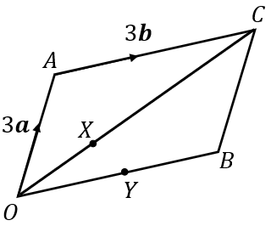 | $OACB$ is a trapezium. $\vec{OA}=a$ and $\vec{AB}=b$. $\vec{OC}=3\vec{AB}$ and $X$ divides the line $OB$ in the ratio $3 : 1$. Show that the points $A, X$ and $C$ are collinear.  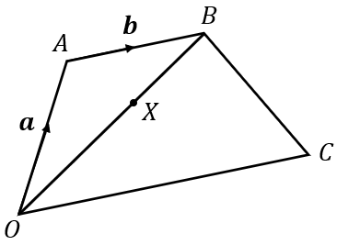
(c) | (d)
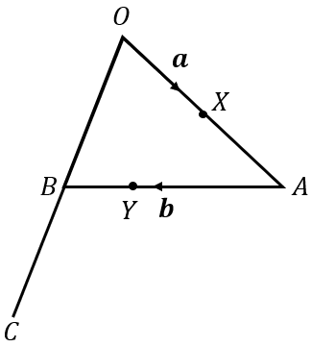  In the triangle $OAB$, $\vec{OX}=a$ and $\vec{AB}=b$. $X$ is the midpoint of OA and the point $Y$ divides the line $AB$ in the ratio $2 : 1$.  $\vec{OB}=\vec{BC}$. Show that the points $X, Y$ and $C$ are collinear. | $\vec{OA}=4a-b$, $\vec{AB}=a+2b$ and $\vec{OC}=a+b$. $\vec{AB}=\vec{BD}$.  The point $X$ divides the line $AC$ in the ratio $6 : 1$. Show that $O, X$ and $D$ are collinear.  