Question 1  How many letters of the word MATHEMATICS do not have any lines of symmetry? |  | Question 2  The diagram shows a poster which Beatrix has (this way up!) on her wall. When Beatrix was standing on her head, looking in a mirror on the opposite wall at the poster on the wall behind her, how many letters could still be read in the normal way?
Question 3  The diagram shows a pattern made from matchsticks stuck to a piece of card. What is the smallest number of matchsticks that need to be added so that the resulting pattern has a line of symmetry? |  | Question 4  The diagram shows a weaver’s design for a rihlélo, a winnowing tray from Mozambique. How many lines of symmetry does the design have?  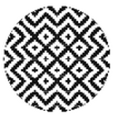
Question 5  What is the smallest number of additional squares which must be shaded so that this figure has at least one line of symmetry and rotational symmetry of order 2?  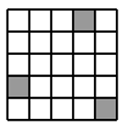 |  | Question 6  Each of the nine small squares in this grid can be coloured completely black or completely white.  What is the largest number of squares that can be coloured black so that the design created has rotational symmetry of order 2, but no lines of symmetry?  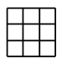
Question 7  The figure shows an equilateral triangle divided into small equilateral triangles, all equal. What is the lowest number of small triangles which must now be shaded to produce a figure which has a line of symmetry?  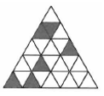 |  | Question 8  A square is divided into eight congruent triangles, as shown. Two of these triangles are selected at random and shaded black. What is the probability that the resulting figure has at least one line of symmetry?  