Finding Angles Using Trigonometry

Find the value of the labelled angles.
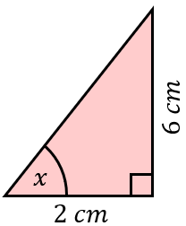
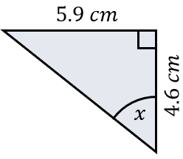
(a) (b)

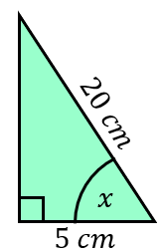
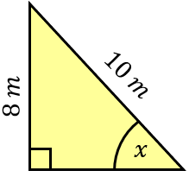
(c) (d)

Find the value of the labelled angles.
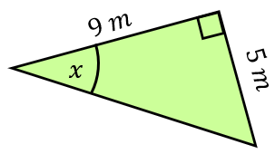
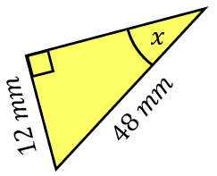
(e) (f)

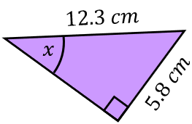

(g)

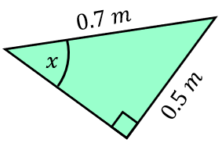
(h)

(i)
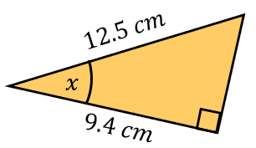

(j)
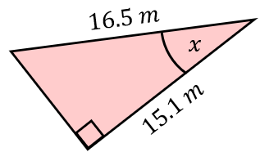

Find the missing angles.
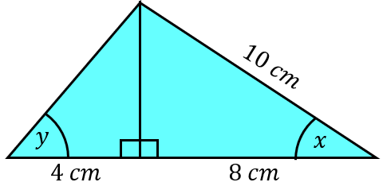
(k)

Finding Angles Using Trigonometry

Find the value of the labelled angles.
(a) (b)

(c) (d)

Find the value of the labelled angles.
(e) (f)

(g)

(h)

(i)

(j)

Find the missing angles.
(k)

