Transformations of Points on Graphs
(a) | (b)
The curve $y=f(x)$ shown below has a minimum point with coordinates $(1, -1)$. Write down the coordinates of the minimum point of the curve $y=f\left(x\right)+3$  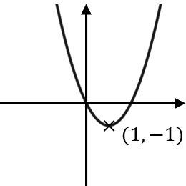 | The point $P$ $(3, 2)$ lies on the curve with equation $y=f(x)$ shown below. Write down the coordinates of the point $P$ on the transformed curve $y=-f(x)$  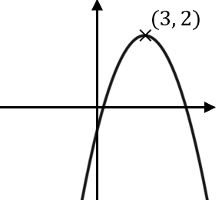
(c) | (d)
The curve $y=f(x)$ shown below has a maximum point with coordinates $(-2, 2)$.  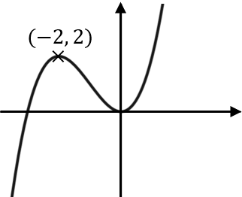  Write down the coordinates of the maximum point of the transformed curve (i) $y=f\left(2x\right)$  (ii) $y=f\left(x+5\right)$ | The curve $y=f(x)$ shown below has a maximum point with coordinates $(0, 3)$.  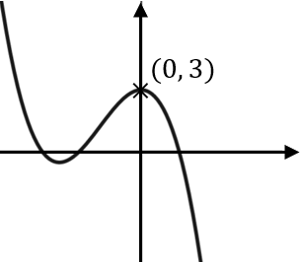  Write down the coordinates of the maximum point of the transformed curve (i) $y=\frac{1}{2}f\left(x\right)$  (ii) $y=f\left(-x\right)$
(e) | (f)
The curve $A$ with equation $y=f(x)$ is transformed to give the curve $B$ with equation $y=f\left(-x\right)+2$. The point $(1, 1)$ lies on the curve $A$. What point does this map to on the transformed curve $B$? | The curve $C$ with equation $y=f(x)$ is transformed to give the curve $D$ with equation $y=-f\left(x+1\right)-2$. The point $(3, -2)$ lies on the curve $C$. What point does this map to on the transformed curve $D$?

