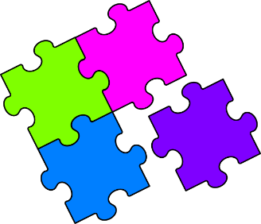
Match-Up
Fractional Indices

1 | $${16}^{1/2}$$ |  | 6 | $${(-1)}^{1/3}$$ |  | 11 | $${\left(\frac{25}{16}\right)}^{1/2}$$
2 | $${27}^{1/3}$$ |  | 7 | $${64}^{1/2}$$ |  | 12 | $${\left(-\frac{1}{27}\right)}^{1/3}$$
3 | $${(-125)}^{1/3}$$ |  | 8 | $${(-8)}^{1/3}$$ |  | 13 | $${\left(\frac{9}{49}\right)}^{1/2}$$
4 | $$1^{1/2}$$ |  | 9 | $${216}^{1/3}$$ |  | 14 | $${\left(-\frac{216}{8}\right)}^{1/3}$$
5 | $${16}^{1/4}$$ |  | 10 | $${625}^{1/4}$$ |  | 15 | $${\left(6\frac{1}{4}\right)}^{1/2}$$
A | $$-1$$ |  | F | $$\frac{5}{2}$$ |  | K | $$-2$$
B | $$\frac{5}{4}$$ |  | G | $$4$$ |  | L | $$-3$$
C | $$-\frac{1}{3}$$ |  | H | $$8$$ |  | M | $$-5$$
D | $$3$$ |  | I | $$2$$ |  | N | $$6$$
E | $$5$$ |  | J | $$\frac{3}{7}$$ |  | P | $$1$$

1 | 2 | 3 | 4 | 5 | 6 | 7 | 8 | 9 | 10 | 11 | 12 | 13 | 14 | 15

