Set Notation and Venn Diagrams
In each question, the values represent the number of elements in each set.
(a) | (b) | (c)
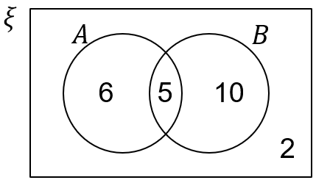  Write down:  (a) $n\left(A∩B\right)$  (b) $n(A)$  (c) $n(B^{'})$  (d) $n(ξ)$ | 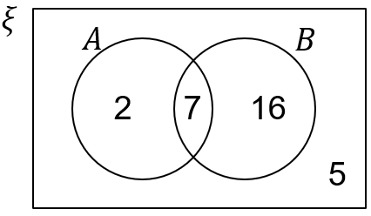  Write down:  (a) $n(B)$  (b) $n(A')$  (c) $n(A∪B)$  (d) $n(A∩B')$ | 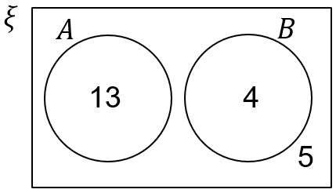  Write down:  (a) $n(A∩B)$  (b) $n(A')$  (c) $n\left(ξ\right)$  (d) $n(A'∩B')$
(d) | (e) | (f)
$$n\left(A∩B\right)=5$$  $$n\left(A\right)=13$$  $$n\left(A∪B\right)=16$$  $n\left(ξ\right)=20$  Draw a Venn diagram to represent this information. | $$n\left(A∩B\right)=7$$  $$n\left(A\right)=13$$  $n\left(B\right)=10$  $$n\left(B'\right)=10$$  Draw a Venn diagram to represent this information. | $n\left(A∩B\right)=10$  $$n\left(A∪B\right)=18$$  $$n\left(A\right)=13$$  $$n\left(ξ\right)=20$$  Draw a Venn diagram to represent this information.
(g) | (h) | (i)
$$n\left(A∪B\right)=20$$  $$n\left(A'\right)=15$$  $$n\left(A∩B\right)=6$$  $$n\left(B\right)=16$$  Draw a Venn diagram to represent this information. | $$n\left(B\right)=7$$  $$n\left(A\right)=10$$  $n\left(A∪B\right)=12$  $$n\left(ξ\right)=20$$  Draw a Venn diagram to represent this information. | $$n\left(A'∩B'\right)=10$$  $n\left(ξ\right)=25$  $$n\left(B\right)=11$$  $$n\left(A\right)=8$$  Draw a Venn diagram to represent this information.

