Surface Areas of Cylinders

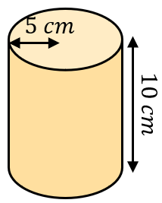
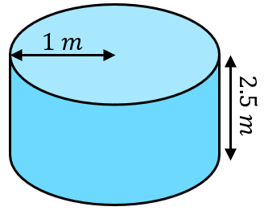
Find the total surface areas of these cylinders.
- (b)

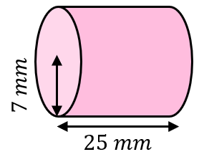
(c)

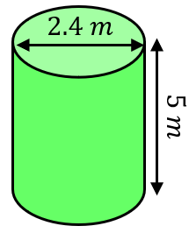
Find the total surface areas of these cylinders.
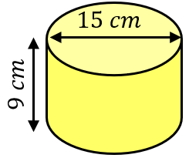
(a) (b)

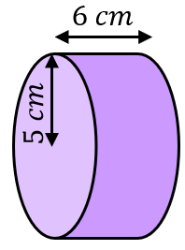
Find the total surface areas of these cylinders, leaving your answer in terms of $π$.
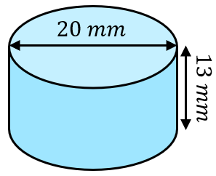
(a) (b)

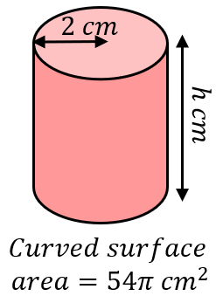
Find the missing lengths in these cylinders.
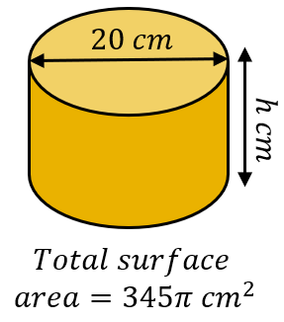
(a) (b)

Surface Areas of Cylinders

Find the total surface areas of these cylinders.
- (b)

(c)

Find the total surface areas of these cylinders.
(a) (b)

Find the total surface areas of these cylinders, leaving your answer in terms of $π$.
(a) (b)

Find the missing lengths in these cylinders.
(a) (b)

