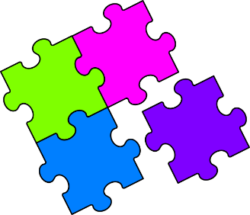
Match-Up
Terminating and Recurring Decimals

1 | $$\frac{3}{10}$$ |  | 6 | $$\frac{8}{25}$$ |  | 11 | $$\frac{104}{333}$$ |  | 16 | $$\frac{14}{45}$$
2 | $$\frac{2}{3}$$ |  | 7 | $$\frac{33}{50}$$ |  | 12 | $$\frac{33}{10}$$ |  | 17 | $$3\frac{3}{100}$$
3 | $$\frac{17}{50}$$ |  | 8 | $$\frac{25}{33}$$ |  | 13 | $$\frac{13}{18}$$ |  | 18 | $$\frac{47}{66}$$
4 | $$\frac{7}{9}$$ |  | 9 | $$\frac{13}{20}$$ |  | 14 | $$\frac{10}{3}$$ |  | 19 | $$3\frac{13}{99}$$
5 | $$\frac{31}{99}$$ |  | 10 | $$\frac{8}{11}$$ |  | 15 | $$\frac{61}{90}$$ |  | 20 | $$\frac{22}{7}$$
A | $$3.3$$ |  | F | $$0.\dot{7}$$ |  | K | $$0.\dot{7}\dot{2}$$ |  | Q | $$0.7\dot{1}\dot{2}$$
B | $$0.65$$ |  | G | $$3.\dot{1}\dot{3}$$ |  | L | $$3.\dot{1}4285\dot{7}$$ |  | R | $$0.\dot{3}\dot{1}$$
C | $$0.34$$ |  | H | $$0.\dot{3}1\dot{2}$$ |  | M | $$3.\dot{3}$$ |  | S | $$0.66$$
D | $$0.\dot{7}\dot{5}$$ |  | I | $$3.03$$ |  | N | $$0.\dot{6}$$ |  | T | $$0.7\dot{2}$$
E | $$0.3\dot{1}$$ |  | J | $$0.32$$ |  | P | $$0.6\dot{7}$$ |  | U | $$0.3$$

1 | 2 | 3 | 4 | 5 | 6 | 7 | 8 | 9 | 10
11 | 12 | 13 | 14 | 15 | 16 | 17 | 18 | 19 | 20

