Solving Equations Graphically
(a)
Plot the graph of $y=6+x-x^{2}$. Use the graph to find the solutions to equation
(a) $6+x-x^{2}=0$ (b) $6+x-x^{2}=-6$
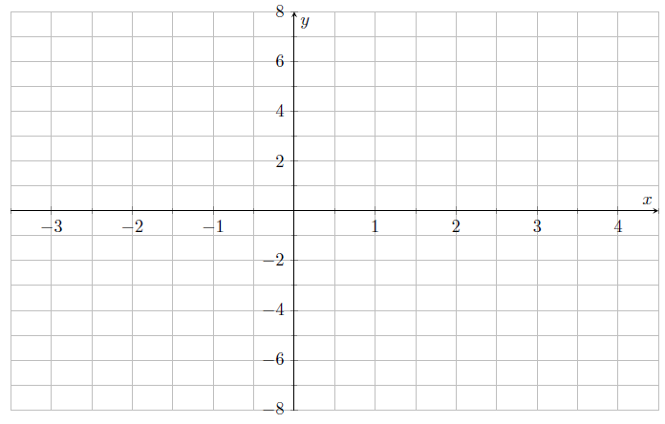
(b)
Plot the graph of $y=x^{2}-4x+3$. Use the graph to find the solutions to equation
(a) $x^{2}-4x+3=0$ (b) $x^{2}-4x+3=8$
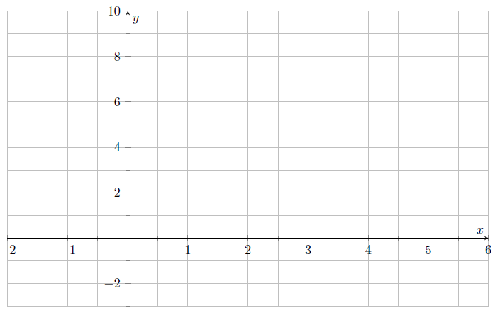

(c)
Plot the graph of $y={8+2x-x}^{2}$. Use the graph to find the solutions to the equation
(a) ${8+2x-x}^{2}=5$ (b) ${8+2x-x}^{2}=8-x$
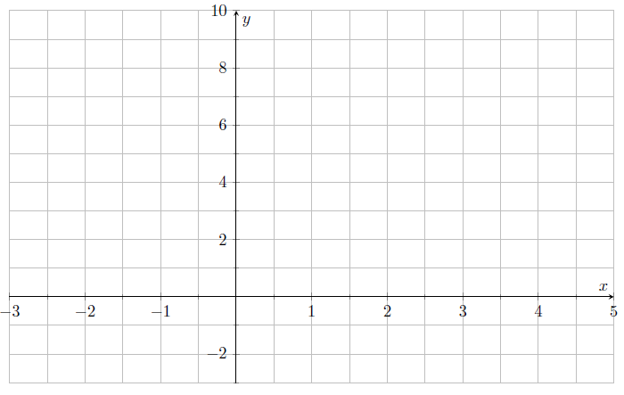
(d)
Plot the graph of $y=x^{3}-3x$. Use the graph to estimate the solutions to the equation
(a) $x^{3}-3x=1$ (b) $x^{3}-3x=x+1$
