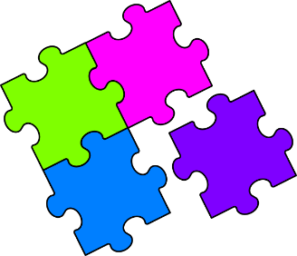
Match-Up
Expanding Brackets with Indices

1 | $$a^{2}(2b+5a)$$ |  | 6 | $$ab^{2}(2b+5a^{2})$$ |  | 11 | $$5a^{2}b^{2}(2a-b)$$
2 | $$2ab(a+5b)$$ |  | 7 | $$2a^{2}(5b^{2}-a^{2})$$ |  | 12 | $$5b^{3}(a^{2}+2b^{2})$$
3 | $$5b^{2}(2a^{2}-b)$$ |  | 8 | $$a^{2}b(5a-{2b}^{3})$$ |  | 13 | $$2a^{2}(b+5a^{4})$$
4 | $$5ab(ab+2)$$ |  | 9 | $$5{ab}^{3}(a+2b^{2})$$ |  | 14 | $$a^{2}b^{2}(5a^{3}-2a)$$
5 | $$2b^{3}(a-5b)$$ |  | 10 | $$2a^{3}(b-5a^{2})$$ |  | 15 | $$5ab^{3}(2b+a^{3})$$
A | $$10a^{2}b^{2}-2a^{4}$$ |  | F | $$5a^{2}b^{3}+10b^{5}$$ |  | K | $$5a^{2}b^{2}+10ab$$
B | $$5a^{5}b^{2}-2a^{3}b^{2}$$ |  | G | $$10a^{3}b^{2}-5a^{2}b^{3}$$ |  | L | $$2a^{3}b-10a^{5}$$
C | $$2{ab}^{3}-10b^{4}$$ |  | H | $$2a^{2}b+5a^{3}$$ |  | M | $$10ab^{4}+5a^{4}b^{3}$$
D | $$2a^{2}b+10{ab}^{2}$$ |  | I | $$2a^{2}b+10a^{6}$$ |  | N | $$5a^{3}b-2a^{2}b^{4}$$
E | $$5a^{2}b^{3}+10ab^{5}$$ |  | J | $$10a^{2}b^{2}-{5b}^{3}$$ |  | P | $$2ab^{3}+5a^{3}b^{2}$$

1 | 2 | 3 | 4 | 5 | 6 | 7 | 8 | 9 | 10 | 11 | 12 | 13 | 14 | 15

