Area of a Circle

Work out the area of each circle, giving your answer to 1 decimal place.
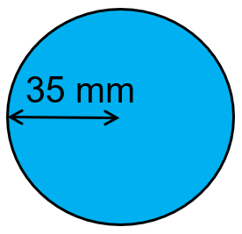
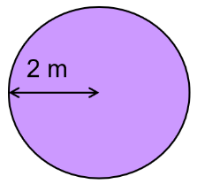
(a) (b)

(c) A circle with radius 13 cm
(d) A frisbee with radius 16.3 cm

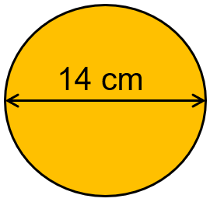
Find the area of each circle, giving your answer to 1 decimal place.
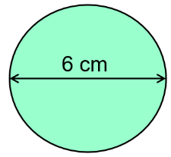
(a) (b)

(c) A circle with a diameter of 45 mm
(d) A plate with diameter 18 cm

Work out the area of each of these shapes, giving your answers to 1 dp.
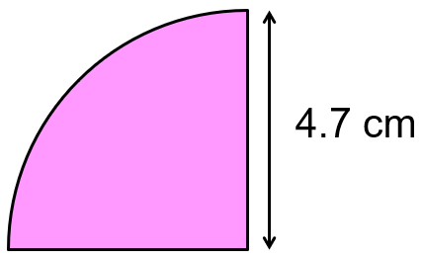
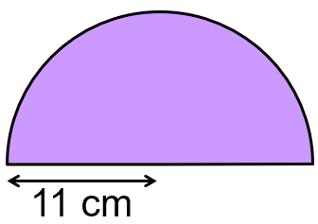
(a) (b)

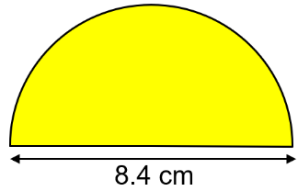
(c)

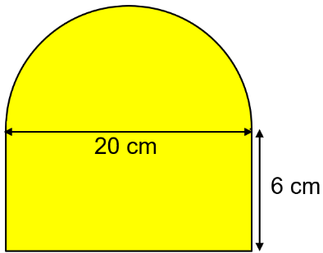
Find the areas of these shapes, leaving your answer in terms of $π$.
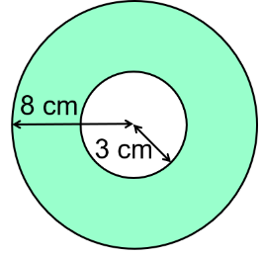
(a) (b)

Anita says ”The area of a circle with radius 8 cm is double the area of a circle with radius 4 cm.” Is she right? Explain.
Area of a Circle

Work out the area of each circle, giving your answer to 1 decimal place.
(a) (b)

(c) A circle with radius 13 cm
(d) A frisbee with radius 16.3 cm

Find the area of each circle, giving your answer to 1 decimal place.
(a) (b)

(c) A circle with a diameter of 45 mm
(d) A plate with diameter 18 cm

Work out the area of each of these shapes, giving your answers to 1 dp.
(a) (b)

(c)

Find the areas of these shapes, leaving your answer in terms of $π$.
(a) (b)

Anita says ”The area of a circle with radius 8 cm is double the area of a circle with radius 4 cm.” Is she right? Explain.

