Finding the Length of the Hypotenuse

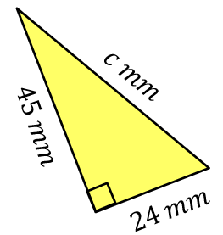
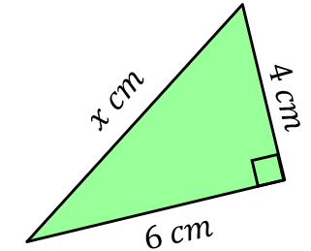
Find each of these lengths, rounding to 1 decimal place when necessary.
(a) (b)

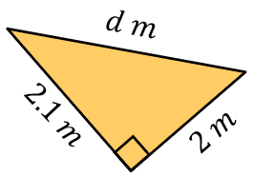
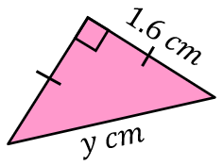
(c) (d)

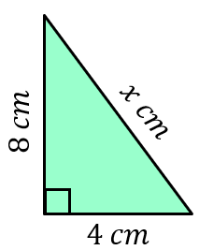
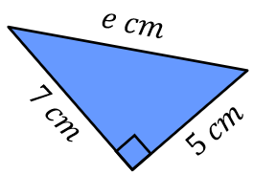
Find each of these lengths, leaving your answers in surd form.
(a) (b)

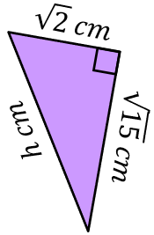
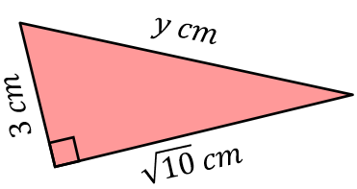
(c) (d)

Find the missing lengths, rounding your answers to 3 significant figures.
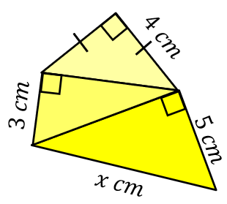
(a) (b)
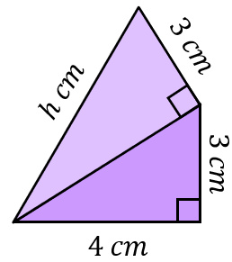

Finding the Length of the Hypotenuse

Find each of these lengths, rounding to 1 decimal place when necessary.
(a) (b)

(c) (d)

Find each of these lengths, leaving your answers in surd form.
(a) (b)

(c) (d)

Find the missing lengths, rounding your answers to 3 significant figures.
(a) (b)

