Surfaces Areas of Prisms

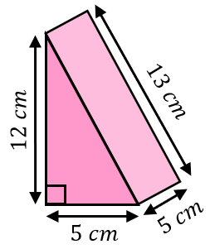
Find the surface area of each of these triangular prisms.
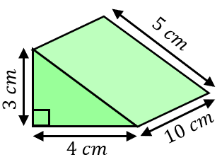
(a) (b)

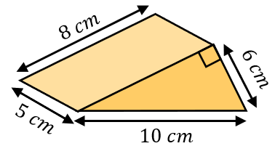
(c)

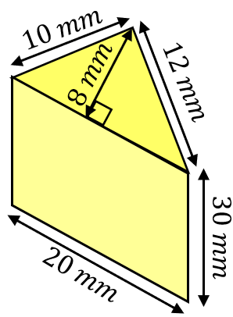
Find the surface area of each of these triangular prisms.
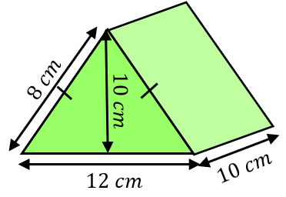
(a) (b)

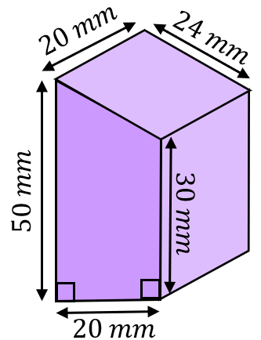
Find the surface areas of these trapezoidal prisms.
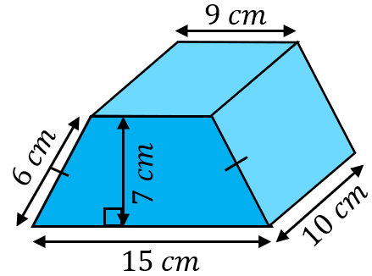
(a) (b)

These two 3D shapes have the same surface area. Find the missing length.
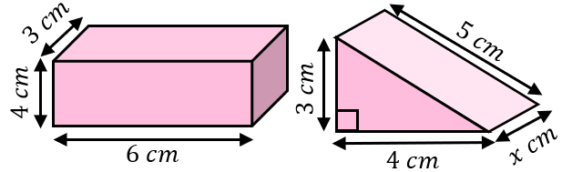

Surfaces Areas of Prisms

Find the surface area of each of these triangular prisms.
(a) (b)

(c)

Find the surface area of each of these triangular prisms.
(a) (b)

Find the surface areas of these trapezoidal prisms.
(a) (b)

These two 3D shapes have the same surface area. Find the missing length.

