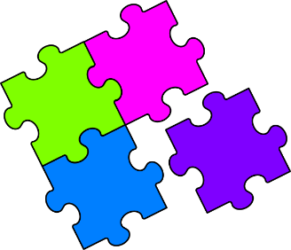
Match-Up
Simplifying Expressions with Powers

1 | $$6×a×a×a$$ |  | 6 | $${2a}^{4}×6a$$ |  | 11 | $$\frac{6a×2ab}{b^{2}}$$
2 | $$2a×4a$$ |  | 7 | $$\frac{6a^{5}}{3a^{3}}$$ |  | 12 | $$3b^{2}×{(2a)}^{2}$$
3 | $$3a×4b$$ |  | 8 | $${(2a)}^{3}$$ |  | 13 | $$\frac{2ab×4a^{2}b}{16ab^{2}}$$
4 | $$2ab×4ab$$ |  | 9 | $${(2a^{2}b)}^{2}$$ |  | 14 | $$\frac{4a^{2}×6b^{2}}{{(2b)}^{3}}$$
5 | $$\frac{8a^{2}}{2a}$$ |  | 10 | $$\frac{12a^{5}}{3a^{2}}$$ |  | 15 | $$\frac{{(2ab)}^{4}×2b}{8a^{2}b^{2}}$$
A | $$\frac{12a^{2}}{b}$$ |  | F | $$6a^{3}$$ |  | K | $$4a^{4}b^{2}$$
B | $$4a$$ |  | G | $$4a^{3}$$ |  | L | $$12ab$$
C | $$8a^{2}b^{2}$$ |  | H | $$\frac{3a^{2}}{b}$$ |  | M | $$8a^{2}$$
D | $$12a^{2}b^{2}$$ |  | I | $$\frac{a^{2}}{2}$$ |  | N | $$2a^{2}$$
E | $$8a^{3}$$ |  | J | $$12a^{5}$$ |  | P | $$4a^{2}b^{3}$$

1 | 2 | 3 | 4 | 5 | 6 | 7 | 8 | 9 | 10 | 11 | 12 | 13 | 14 | 15

