Area and Perimeter of 2D Shapes

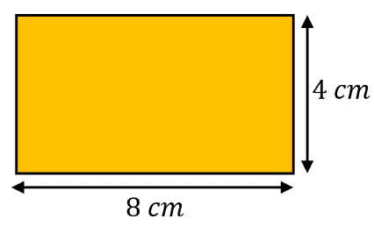
Find the area and perimeter of each of these shapes.
(a)

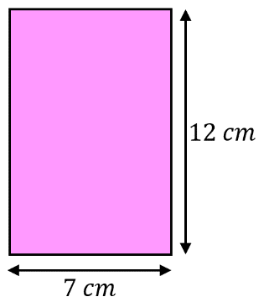
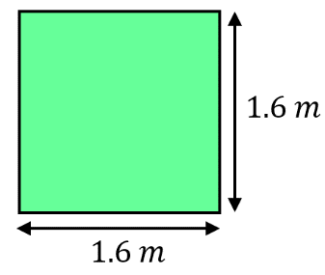
(b) (c)

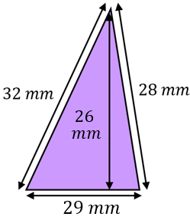
Find the area and perimeter of each of these shapes.
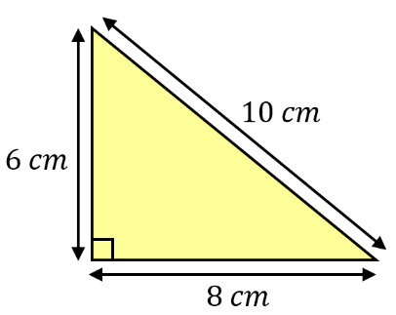
(a) (b)

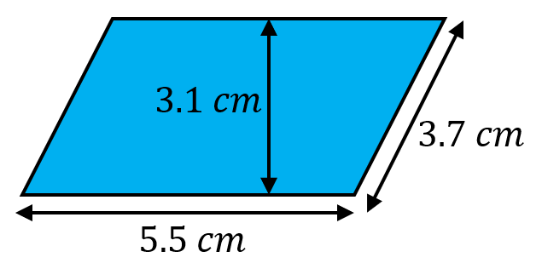
(c)

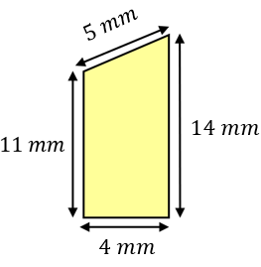
Find the area and perimeter of each of these shapes.
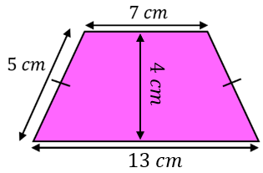
(a) (b)

A rectangle has an area of $32 {cm}^{2}$ and its length and width are both integers. What is the largest perimeter it could have?
Area and Perimeter of 2D Shapes

Find the area and perimeter of each of these shapes.
(a)

(b) (c)

Find the area and perimeter of each of these shapes.
(a) (b)

(c)

Find the area and perimeter of each of these shapes.
(a) (b)

A rectangle has an area of $32 {cm}^{2}$ and its length and width are both integers. What is the largest perimeter it could have?

