Constructing Triangles

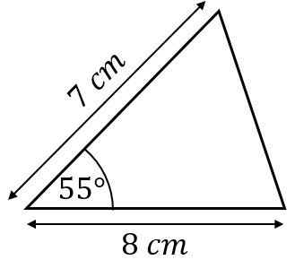
Construct the following triangles.
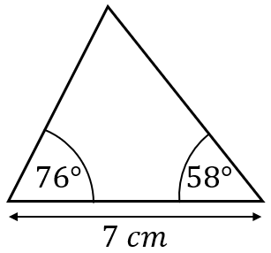
(a) (b)

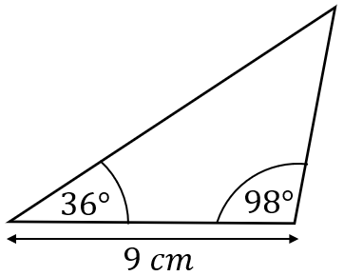
(c)

Construct the following triangles.
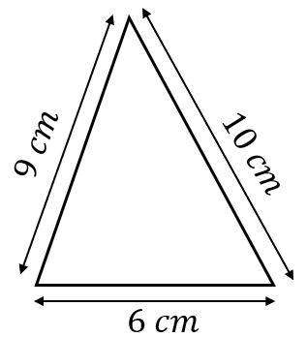
(a)

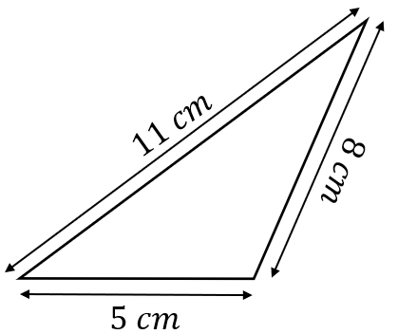
(b)

(a) In the triangle$ABC$, $AB$ is $7 cm$, $BC$is $6 cm$ and angle $ABC$ is $65°$. Make and accurate construction of the triangle.
(b) In the triangle $DEF$, $DE$ is $6 cm$, $EF$ is $8 cm$ and $DF$ is $10 cm$. Make an accurate construction of the triangle. Measure the angle $DEF$.

In the triangle $KLM$, $KL$ is $7 cm$, $LM$ is $8 cm$ and angle $LKM$ is $40°$. Construct the two possible triangles accurately. Measure the angle $KLM$ in both triangles. What do you notice?
Constructing Triangles

Construct the following triangles.
(a) (b)

(c)

Construct the following triangles.
(a)

(b)

(a) In the triangle$ABC$, $AB$ is $7 cm$, $BC$is $6 cm$ and angle $ABC$ is $65°$. Make and accurate construction of the triangle.
(b) In the triangle $DEF$, $DE$ is $6 cm$, $EF$ is $8 cm$ and $DF$ is $10 cm$. Make an accurate construction of the triangle. Measure the angle $DEF$.

In the triangle $KLM$, $KL$ is $7 cm$, $LM$ is $8 cm$ and angle $LKM$ is $40°$. Construct the two possible triangles accurately. Measure the angle $KLM$ in both triangles. What do you notice?

