Plotting Coordinate Letters
(a) | (b)
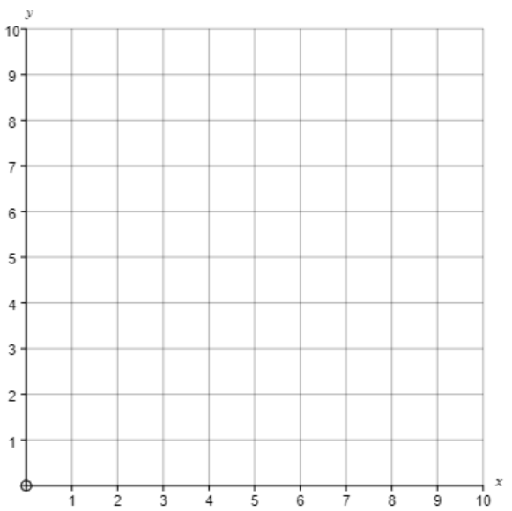
Join the following points in order:  (2, 5) (3, 5) (3, 9) (2, 9) (2, 5)  Join the following points in order:  (5, 6) (5, 5) (6, 5) (6, 2) (7, 2) (7, 5) (8, 5) (8, 6) (5, 6) | Join the following points in order:  (5, 5) (5, 6) (3, 6) (3, 9) (2, 9) (2, 5) (5, 5)  Join the following points in order:  (6, 1) (7, 1) (7, 4) (8, 4) (8, 1) (9, 1) (9, 5) (6, 5) (6, 1)
(c) | (d)
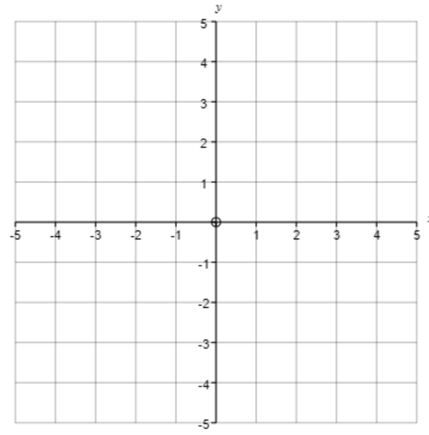
Join the following points in order:  (2, -2) (3, -2) (3, 1) (4, 1) (4, 2) (1, 2) (1, 1) (2, 1) (2, -2)  Join the following points in order:  (-4, -1) (-3, -1) (-3, 1) (-1, 1) (-1, 4) (-4, 4) (-4, -1)  Join the following points in order:  (-3, 2) (-2, 2) (-2, 3) (-3, 3) (-3, 2) | Join the following points in order:  (-4, -2) (-1, -2) (-1, 2) (-4, 2) (-4, -2)  Join the following points in order:  (-3, -1) (-2, -1) (-2, 1) (-3, 1) (-3, -1)  Join the following points in order:  (1, -3) (4, -3) (4, 3) (1, 3) (1, 0) (3, 0) (3, -2) (1, -2) (1, -3)  Join the following points in order:  (2, 1) (3, 1) (3, 2) (2, 2) (2, 1)
Rearrange the letters to make a related mathematical word.

