Fill In The Blanks…
Adding and Subtracting Mixed Numbers

Question | Write as Improper Fractions | Convert to Common Denominator | Answer as Improper Fraction | Answer as  Mixed Number
$$1\frac{1}{3}+2\frac{1}{2}$$ | $$\frac{4}{3}+\frac{5}{2}$$ | $$\frac{8}{6}+\frac{15}{6}$$ | $$\frac{23}{6}$$
$$3\frac{2}{3}+1\frac{1}{4}$$ | $$\frac{11}{3}+\frac{5}{4}$$ | $$\frac{44}{12}+\frac{15}{12}$$
$$4\frac{1}{2}-3\frac{2}{5}$$ | $$\frac{9}{2}-\frac{17}{5}$$ | 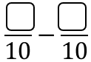
$$2\frac{3}{4}+1\frac{5}{6}$$ | $$\frac{11}{4}+\frac{11}{6}$$
$$5\frac{1}{3}-3\frac{2}{5}$$
$$4\frac{3}{4}-2\frac{5}{7}$$
$$2\frac{8}{9}+3\frac{3}{5}$$
$$2\frac{13}{20}-\frac{7}{8}$$
 | $$\frac{7}{4}+\frac{12}{5}$$
 | 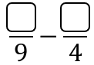 | $$\frac{100}{36}-\frac{45}{36}$$
 | 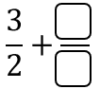 |  | $$\frac{29}{10}$$
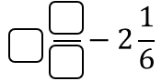 |  |  |  | $$3\frac{7}{30}$$

