Volume and Surface Area of Cuboids

Find the volume and surface area of each of these cubes or cuboids.
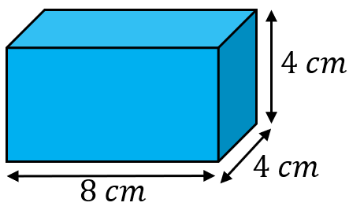
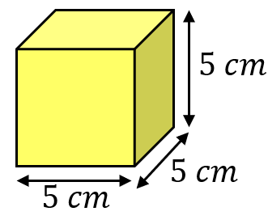
(a) (b)

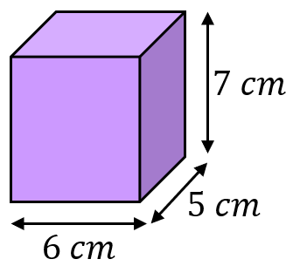
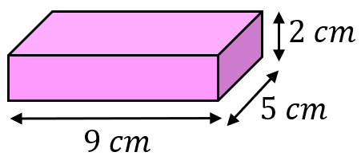
(c) (d)

Find the volume and surface area of each of these cubes or cuboids.
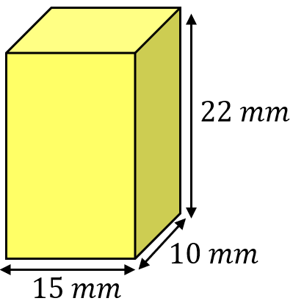
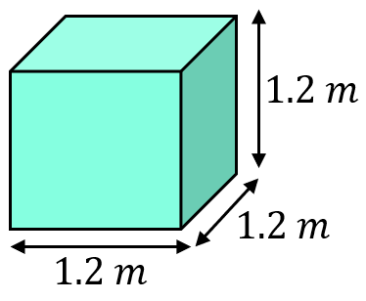
(a) (b)

(c)
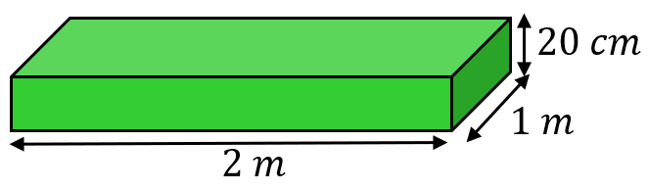

Find the missing lengths in these cubes and cuboids.
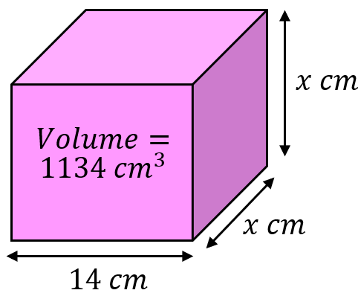
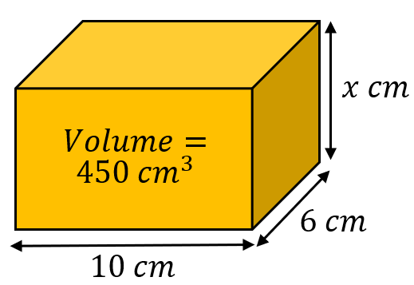
(a) (b)

(a) A cube has a volume of $5832 {cm}^{3}$. Find its side length.
(b) A cuboid with side lengths, $x cm, 5 cm$ and $8 cm$ has a surface area of $197 {cm}^{2}.$ Find $x$.
Volume and Surface Area of Cuboids

Find the volume and surface area of each of these cubes or cuboids.
(a) (b)

(c) (d)

Find the volume and surface area of each of these cubes or cuboids.
(a) (b)

(c)

Find the missing lengths in these cubes and cuboids.
(a) (b)

(a) A cube has a volume of $5832 {cm}^{3}$. Find its side length.
(b) A cuboid with side lengths, $x cm, 5 cm$ and $8 cm$ has a surface area of $197 {cm}^{2}.$ Find $x$.

