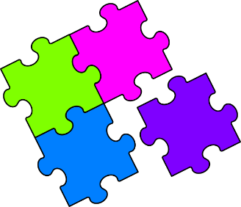
Match-Up
Expanding Double Brackets

1 | $$(x+4)(x+3)$$ |  | 7 | $$(x+3)(x-3)$$ |  | 13 | $$(x-7)(x-1)$$
2 | $$(x+2)(x+6)$$ |  | 8 | $$(x-6)(x-2)$$ |  | 14 | $$(4+x)(x-3)$$
3 | $$(x+1)(x+7)$$ |  | 9 | $$(x-3)(x-4)$$ |  | 15 | $$(x+4)(2x+3)$$
4 | $$(x-6)(x+2)$$ |  | 10 | $${(x+1)}^{2}$$ |  | 16 | $$(2x+1)(x+3)$$
5 | $$(x-4)(x+3)$$ |  | 11 | $$(x-1)(x+1)$$ |  | 17 | $$(2x+3)(x-4)$$
6 | $$(x-1)(x+7)$$ |  | 12 | $${(x-3)}^{2}$$ |  | 18 | $${(2x+3)}^{2}$$
A | $$x^{2}-9$$ |  | G | $$x^{2}+6x-7$$ |  | M | $$x^{2}+8x+7$$
B | $$x^{2}-7x+12$$ |  | H | $$x^{2}-1$$ |  | N | $${2x}^{2}-5x-12$$
C | $$4x^{2}+12x+9$$ |  | I | $${2x}^{2}+7x+3$$ |  | P | $$x^{2}-6x+9$$
D | $$x^{2}-8x+7$$ |  | J | $$x^{2}+7x+12$$ |  | Q | $$x^{2}-4x-12$$
E | $${2x}^{2}+11x+12$$ |  | K | $$x^{2}-8x+12$$ |  | R | $$x^{2}-x-12$$
F | $$x^{2}+2x+1$$ |  | L | $$x^{2}+8x+12$$ |  | S | $$x^{2}+x-12$$

1 | 2 | 3 | 4 | 5 | 6 | 7 | 8 | 9 | 10 | 11 | 12 | 13 | 14 | 15 | 16 | 17 | 18

