Volume and Surface Area of Cylinders

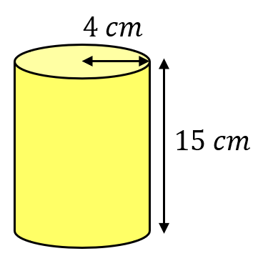
Find the volume and total surface area of each of these cylinders.
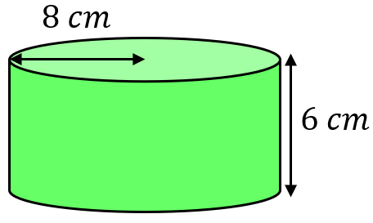
(a) (b)

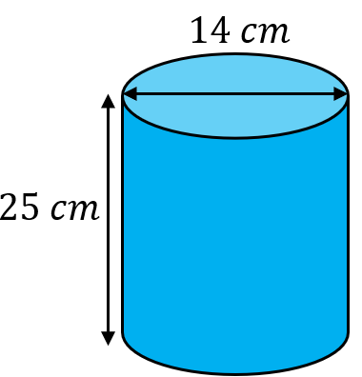
(c) (d)
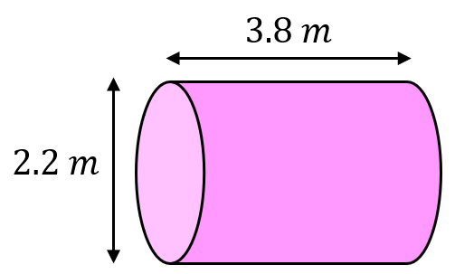

(a) Find the volume and surface area of a soup tin with a radius of 4.5 cm and a height of 12.5 cm.
(b) Find the volume and curved surface area of a glue stick with a diameter of 26 mm and a height of 70 mm.

Find the missing lengths.
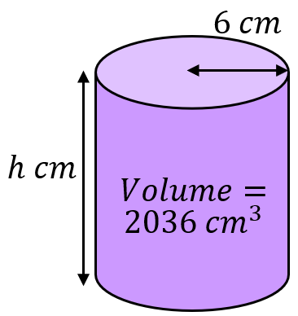
(a) (b)
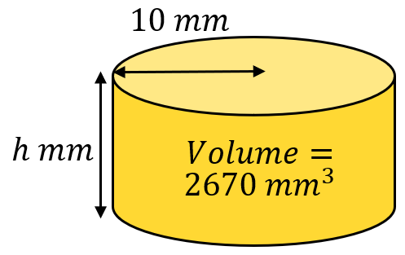

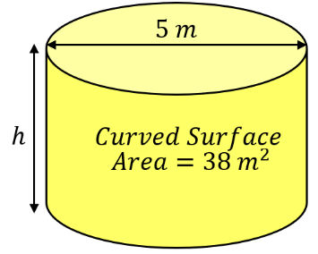
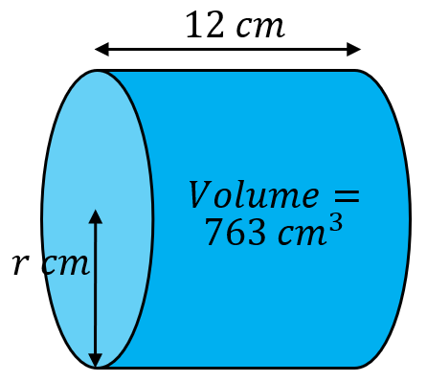
(c) (d)

A cylinder has a height of $16 cm$ and a curved surface area of $452 {cm}^{2}.$ Find its volume.

Volume and Surface Area of Cylinders

Find the volume and total surface area of each of these cylinders.
(a) (b)

(c) (d)

(a) Find the volume and surface area of a soup tin with a radius of 4.5 cm and a height of 12.5 cm.
(b) Find the volume and curved surface area of a glue stick with a diameter of 26 mm and a height of 70 mm.

Find the missing lengths.
(a) (b)

(c) (d)

A cylinder has a height of $16 cm$ and a curved surface area of $452 {cm}^{2}.$ Find its volume.

