Vectors and Ratio
(a) |  | (b)
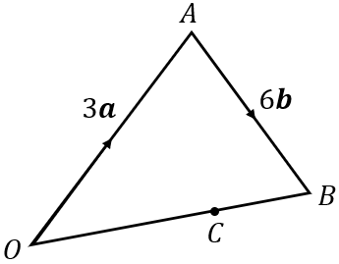  In the triangle $OAB$, $\vec{OA}=3a$ and $\vec{AB}=6b$. The point $C$ divides the line $OB$ in the ratio $2 : 1$.  Express the following in terms of $a$and $b$: |  | $OABC$ is a trapezium, where $\vec{OA}=2a$ and $\vec{AB}=2b$. $\vec{OC}=2\vec{AB}$ and $D$ splits the line $BC$ in the ratio $1 : 3$.  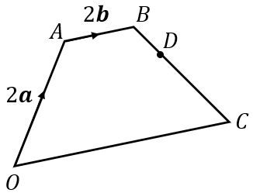  Express the following in terms of $a$and $b$:
(a) $\vec{OB}$ | (b) $\vec{OC}$ | (a) $\vec{BO}$ | (b) $\vec{BC}$
(c) $\vec{BC}$ | (d) $\vec{AC}$ | (c) $\vec{BD}$ | (d) $\vec{DO}$
(c) |  | (d)
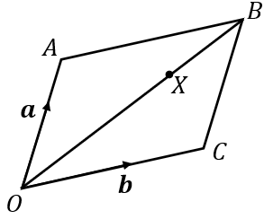  In the parallelogram $OABC$, $\vec{OA}=a$ and $\vec{OC}=b$. The point $X$ divides the line $OB$ in the ratio $3 : 2$.  Express the following in terms of $a$and $b$: |  | $OABC$ is a quadrilateral.  $\vec{OA}=a,$ $\vec{OC}=b$ and $\vec{CB}=c$.  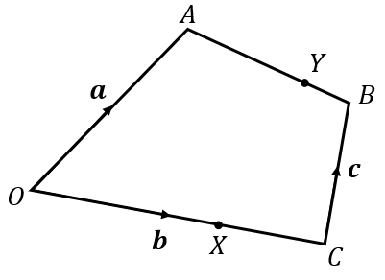  The point $X$ divides the line $OC$ in the ratio $2 : 1$. The point $Y$ divides the line $AB$ in the ratio  $3 : 1$.  Express the following in terms of $a, b$and $c$:
(a) $\vec{AB}$ | (b) $\vec{OB}$ | (a) $\vec{OX}$ | (b) $\vec{XC}$
(c) $\vec{OX}$ | (d) $\vec{BX}$ | (c) $\vec{AB}$ | (d) $\vec{AY}$
(e) $\vec{AX}$ | (f) $\vec{XC}$ | (e) $\vec{AX}$ | (f) $\vec{XY}$

