Plotting Linear Graphs Using the Cover-Up Method
(a) $2x+y=6$ | (b) $x+3y=9$
When $x=0, y=$ | When $x=0, y=$
When $y=0, x=$ | When $y=0, x=$
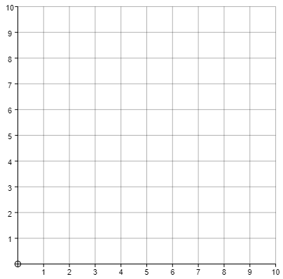
(c) $5x+2y=10$ | (d) $3x+2y=9$
When $x=0, y=$ | When $x=0, y=$
When $y=0, x=$ | When $y=0, x=$
