Angles in Regular Polygons
All polygons are regular. Find the missing angles in each of the diagrams.
(a) | (b) | (c) | (d)
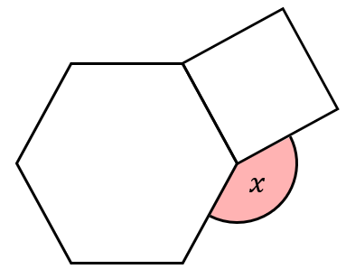 | 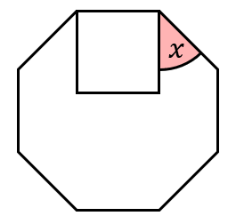 | 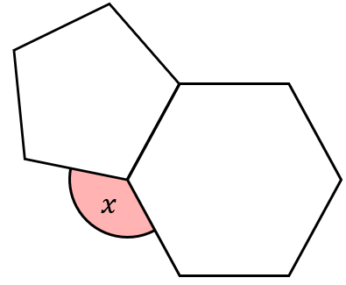 | 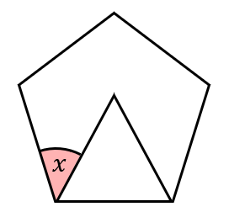
(e) | (f) | (g) | (h)
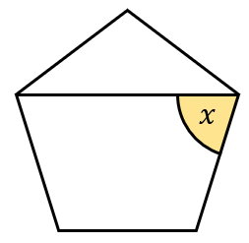 | 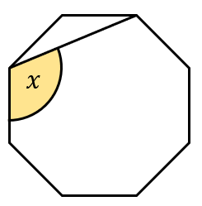 | 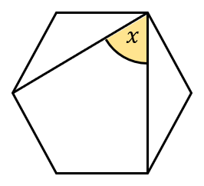 | 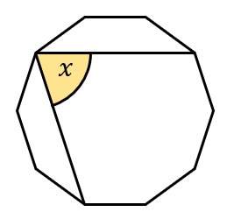
(i) | (j) | (k) | (l)
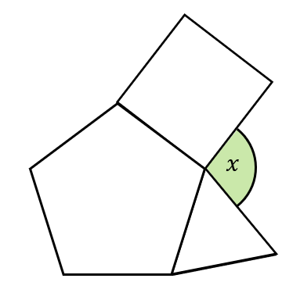 | 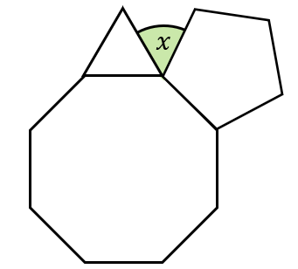 | 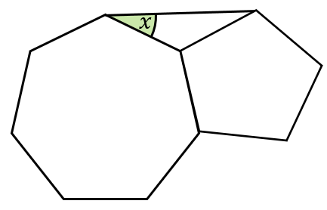 | Find the number of sides of the incomplete regular polygon.  