Defining Vectors
Decode the Maths Joke
Each vector in terms of $a$ and $b$ defines a path which starts at X and ends at a given letter. Find each of the letters and then decode the joke.
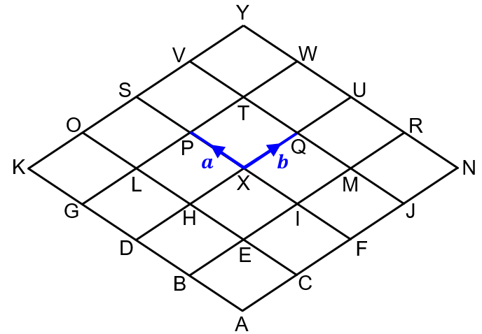

Vector | $$a+2b$$ | $$-b$$ | $$-a-b$$ | $$-a+2b$$ | $$-a-b$$ |  | $$-2b$$
Letter
Vector | $$2a-b$$ |  | $$-a+b$$ | $$-2a-2b$$ | $$a+b$$ | $$-b$$ | $$2a$$
Letter
Vector | $$a+b$$ | $$-a-b$$ | $$-2a-2b$$ | $$-2a-b$$ | $$-b$$ | $$-a-b$$ | $$-a+2b$$
Letter
Vector | $$2a$$ |  | $$a-2b$$ | $$2a-b$$ |  | $$2a-b$$ | $$-2a+2b$$
Letter
Vector | $$-b$$ | $$2a-b$$ | $$a-b$$ | $$-a$$ | $$-2b$$ | $$-2a-2b$$ | $$2a+2b$$
Letter
Vector | ? |  | $$a+b$$ | $$-a$$ | $$-a+b$$ | $$-a-b$$ | $$2a$$
Letter
Vector | $$2a$$ | $$b$$ | $$2b$$ | $$-2a-2b$$ | $$-a+2b$$ | $$-a-b$$ | !
Letter

