Fill In The Blanks…
Inverse Two-Step Functions

Question | Function Machines |  |  |  | Answer
$$f\left(x\right)=3x-1$$  Find $f^{-1}(x)$ | 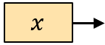 | 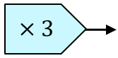 | 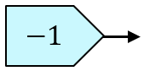 | 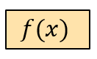 | $$f^{-1}\left(x\right)=$$  $$\frac{x+1}{3}$$
 | 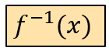 | 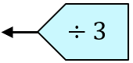 | 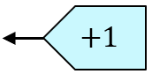 | 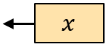
$$f\left(x\right)=x^{2}-5$$  Find $f^{-1}(x)$ |  | 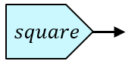 | 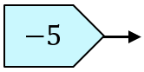 |  | $$f^{-1}\left(x\right)=$$
 |  | 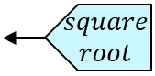 | 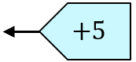
$$f\left(x\right)=\frac{x-3}{2}$$  Find $f^{-1}(x)$ |  | 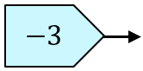 | 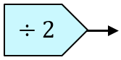 |  | $$f^{-1}\left(x\right)=$$
 |  | 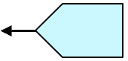
$$f\left(x\right)=5(x+2)$$  Find $f^{-1}(x)$ |  | 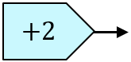 | 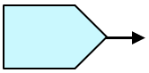 |  | $$f^{-1}\left(x\right)=$$
$$g\left(x\right)=\frac{x}{4}+7$$  Find $g^{-1}(x)$ |  |  |  | 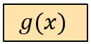 | $$g^{-1}\left(x\right)=$$
 | 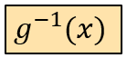
$$f\left(x\right)=5x^{2}$$  Find $f^{-1}(x)$ |  |  |  |  | $$f^{-1}\left(x\right)=$$
$$h\left(x\right)=\frac{1}{x}-2$$  Find $h^{-1}(x)$ |  |  |  | 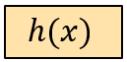 | $$h^{-1}\left(x\right)=$$
 | 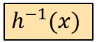
$$f\left(x\right)={(x-4)}^{3}$$  Find $f^{-1}(x)$ |  |  |  |  | $$f^{-1}\left(x\right)=$$

