Volume of Cuboids Challenge
Given the volumes of these six cuboids, can you work out the measurements, $a, b, c$ and $d$? Explain how you got your answers.
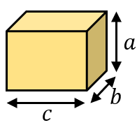  $$Volume=1512 {cm}^{3}$$ | 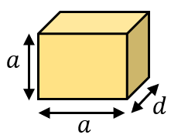  $$Volume=648 {cm}^{3}$$ | 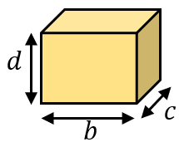  $$Volume=1344 {cm}^{3}$$
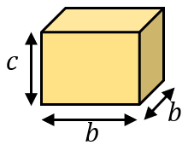  $$Volume=2016 {cm}^{3}$$ | 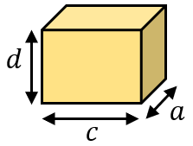  $$Volume=1008 {cm}^{3}$$ | 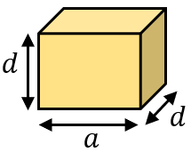  $$Volume=576 {cm}^{3}$$
$$a=$$
$$b=$$
$$c=$$
$$d=$$
How many more cubes and cuboids can you create using only these four dimensions. Find the volume of each cube or cuboid you find.

-----------------------------------------------------------------------------------------------------

CLUE 1 | CLUE 2 | CLUE 3
The order of measurements from smallest to biggest is $d, a, b, c$ | A rectangle with width $b$ and length $c$ has an area of $168 {cm}^{2}.$ | The volume of a cube with side length $a$ is $729 {cm}^{3}$.

