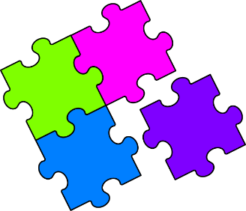
Match-Up
Area of a Circle

1 | Find the area of a circle with a radius of $11 cm$, giving your answer to 1 decimal place. |  | A | $$9.6 m^{2}$$
2 | Find the area of a circle with a diameter of $45 cm$, giving your answer to the nearest ${cm}^{2}$. |  | B | $$157.1 cm^{2}$$
3 | Find the area of a circle with a diameter of $3.5 m$, giving your answer to 1 decimal place. |  | C | $$615.8 {mm}^{2}$$
4 | Find the area of a circle with a radius of $1.6 m$, giving your answer to 1 decimal place. |  | D | $$293.1 cm^{2}$$
5 | A coin has a radius of $14 mm$. Find the area of the coin to 1 decimal place. |  | E | $${616 m}^{2}$$
6 | The lid of a jam jar has a diameter of $86 mm$. Find the area of the lid to the nearest ${mm}^{2}$. |  | F | $$380.1 {cm}^{2}$$
7 | A roundabout has a diameter of $28 metres$. Find the area of the roundabout to the nearest $m^{2}$. |  | G | $$1810 {mm}^{2}$$
8 | A circular pond has a radius of $5.5 m$. Find the area of the pond to 1 decimal place. |  | H | $$8.0 m^{2}$$
9 | Find the area of a semi-circle with a radius of $10 cm$ to 1 decimal place. |  | I | $$5809 {mm}^{2}$$
10 | A semi-circular lawn has a diameter of $13 m$. Find the area of the lawn to the nearest square metre. |  | J | $$95.0 m^{2}$$
11 | A quarter circle has a radius of $48 mm$. Find the area of the quarter circle to the nearest ${mm}^{2}$. |  | K | $$1590 {cm}^{2}$$
12 | A compound shape is made up of a semi-circle with diameter $12 cm$ attached to a rectangle with dimensions $12 cm$ by $15 cm$. Find the total area to 1 decimal place. |  | L | $$66.4 m^{2}$$

1 | 2 | 3 | 4 | 5 | 6 | 7 | 8 | 9 | 10 | 11 | 12

