Pythagoras’ Theorem

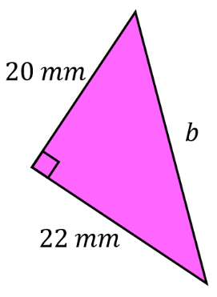
Find the missing lengths.
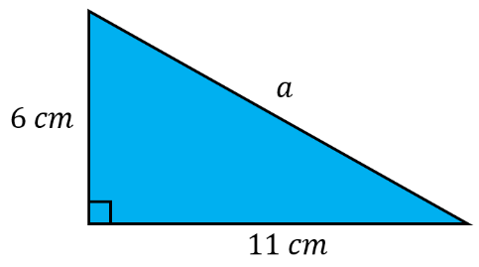
(a) (b)

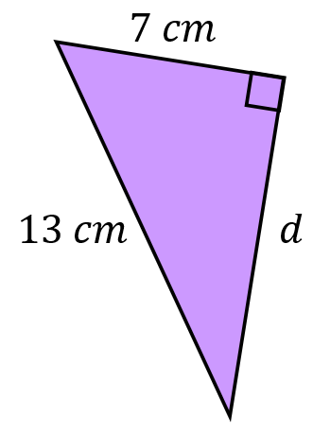
Find the missing lengths.
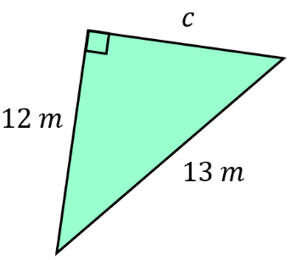
(a) (b)

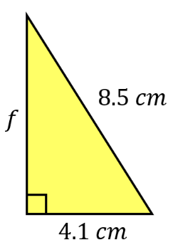
Find the missing lengths.
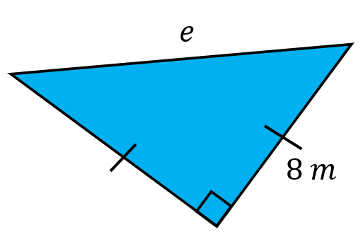
(a) (b)

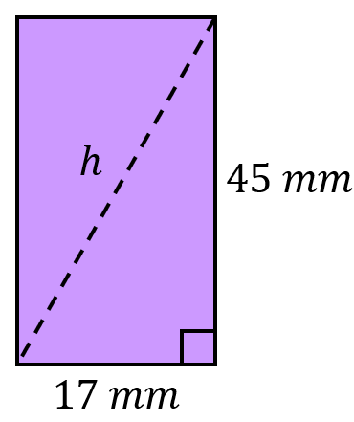
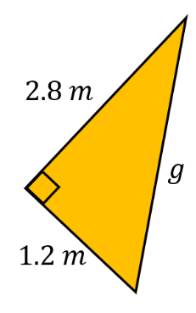
(c) (d)

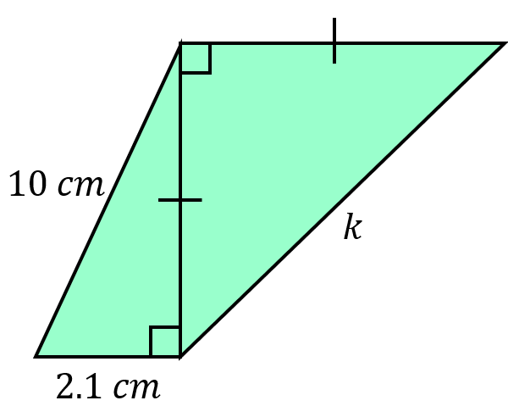
Find the missing lengths.
(b)
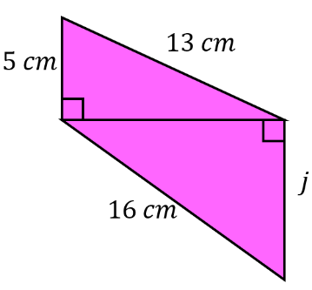
(a)

Pythagoras’ Theorem

Find the missing lengths.
(a) (b)

Find the missing lengths.
(a) (b)

Find the missing lengths.
(a) (b)

(c) (d)

Find the missing lengths.
(b)
(a)

