Plotting Linear Graphs
(a) |  |  |  |  |  | (b)
$$x$$ | $$0$$ | $$1$$ | $$2$$ | $$3$$ | $$4$$ | $$x$$ | $$0$$ | $$1$$ | $$2$$ | $$3$$ | $$4$$
$$y=x+1$$ |  |  |  |  |  | $$y=8-x$$
$$y=x+2$$ |  |  |  |  |  | $$y=7-x$$
$$y=x+3$$ |  |  |  |  |  | $$y=6-x$$
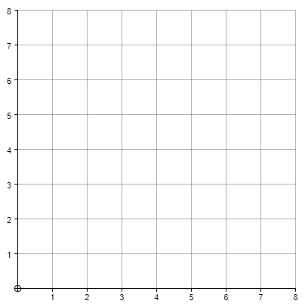
(c) |  |  |  |  |  | (d)
$$x$$ | $$0$$ | $$1$$ | $$2$$ | $$3$$ | $$4$$ | $$x$$ | $$0$$ | $$1$$ | $$2$$ | $$3$$ | $$4$$
$$y=0.5x$$ |  |  |  |  |  | $$y=8-0.5x$$
$$y=x$$ |  |  |  |  |  | $$y=8-x$$
$$y=2x$$ |  |  |  |  |  | $$y=8-2x$$

