Fill In The Blanks…
Composite Two-Step Functions

Question | Input | 1st Function |  | 2nd Function |  | Output | Answer
$$f\left(x\right)=3x-1$$  $$g\left(x\right)=x^{2}+5$$  Find $fg(x)$ | 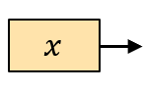 | 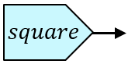 | 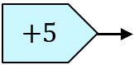 | 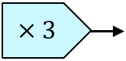 | 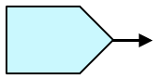 | 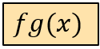 | $$fg\left(x\right)$$  $$=3\left(x^{2}+5\right)-1$$  $$=3x^{2}+14$$
$$f\left(x\right)=2\sqrt{x}$$  $$g\left(x\right)=4x-3$$  Find $gf(x)$ |  | 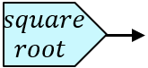 |  |  |  | 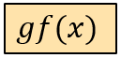 | $$gf\left(x\right)$$  $$=$$
$$f\left(x\right)=\frac{x}{2}+1$$  $$g\left(x\right)=3x^{2}$$  Find $fg(x)$ |  |  |  |  |  |  | $$fg\left(x\right)$$  $$=$$
$$g\left(x\right)=\frac{1}{x-2}$$  $$h\left(x\right)=4\sqrt{x}$$  Find $hg(x)$ |  |  |  |  |  | 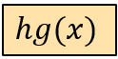
$$f\left(x\right)=5x^{2}$$
$$g\left(x\right)=2x-1$$
Find $fg(x)$

