Sketching Quadratic Graphs
- Sketch the graph of $y=x^{2}-2x-3$
Shape – Is it $∪$-shaped or $∩$-shaped?
Y-Axis – Find out where it crosses the y-axis by putting $x=0$.
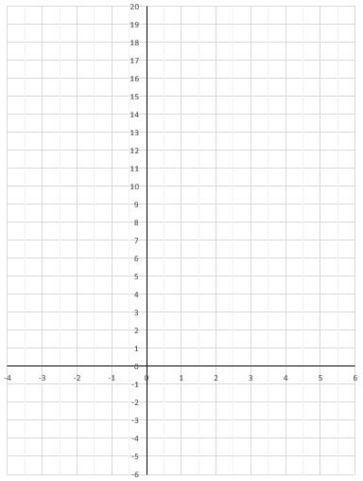

Turning Point– Complete the square into the format ${(x-p)}^{2}+q$ where the turning point is $(p,q)$
X-Axis – Find out where it crosses the x-axis by putting $y=0$, then solving the quadratic equation.

- Sketch the graph of $y=x^{2}-6x-16$
Y-Axis – Find out where it crosses the y-axis by putting $x=0$.
Shape – Is it $∪$-shaped or $∩$-shaped?
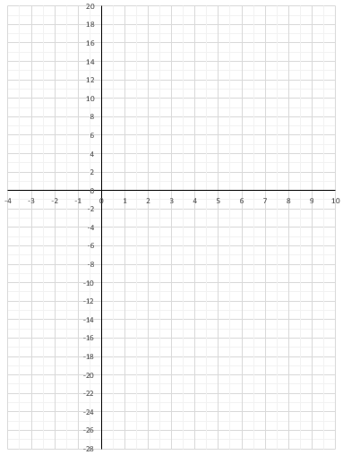
Turning Point– Complete the square into the format ${(x-p)}^{2}+q$ where the turning point is $(p,q)$
X-Axis – Find out where it crosses the x-axis by putting $y=0$, then solving the quadratic equation.
- Sketch the graph of $y={12+4x-x}^{2}$
Y-Axis – Find out where it crosses the y-axis by putting $x=0$.
Shape – Is it $∪$-shaped or $∩$-shaped?
Turning Point– Complete the square into the format $q-{(x-p)}^{2}$ where the turning point is $(p,q)$
X-Axis – Find out where it crosses the x-axis by putting $y=0$, then solving the quadratic equation.

- Sketch the graph of $y={2x}^{2}-4x+7$
Y-Axis – Find out where it crosses the y-axis by putting $x=0$.
Shape – Is it $∪$-shaped or $∩$-shaped?
Turning Point– Complete the square into the format $a{\left(x-p\right)}^{2}+q$ where the turning point is $(p,q)$
X-Axis – Find out where it crosses the x-axis by putting $y=0$, then solving the quadratic equation.

