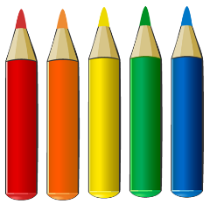
Pixel Picture

Simplifying Ratios

11:22 | 7.5:5 | 24:48 | 5:10 | 19:38 | 78:52 | 8:16
6:12 | 81:54 | 9:18 | 20:40 | 15:30 | 54:36 | 16:32
30:60 | 0.6:0.4 | 24:16 | 99:66 | 33:22 | 4.5:3 | 4:8
27:54 | 1.5:1 | 6:9 | 21:14 | 8:12 | 27:18 | 10:20
3:6 | 66:44 | 60:40 | 45:30 | 36:24 | 90:60 | 7:14
0.5:1 | 42:28 | 75:50 | 12:4 | 48:32 | 12:8 | 1.5:3
17:34 | 6:4 | 30:20 | 9:6 | 15:10 | 18:12 | 2:4

Colour pink all the ratios that simplify to $3 :1$
Colour black all the ratios that simplify to $2 :3$
Colour grey all the ratios that simplify to 3$:2$
Colour blue all the ratios that simplify to 1$:2$

